# The TYNDP: mapping the Energy Union

“The EU has set itself the targets, by 2030, of reducing domestic greenhouse gas emissions by 40% […], reaching at least 27% energy savings, [and]at least 27% renewable energy (RES) penetration at EU level” (Energy Union Package)

ENTSO-E’s 10-year network development plan (TYNDP) is about defining what grid the EU needs to fulfil its climate and energy objectives. The first step is to study how the “27/27/40” goals by 2030 will affect the power sector taking into account its specificities. This is what the TYNDP scenario development is about.

The scenarios used for the 2016 edition of the TYNDP build on the ones used two-years ago. The focus is on the exploration of the 2030 horizon. The data and some assumptions used in the TYNDP 2014 have been updated but the four storylines or “Visions for 2030” have been kept. An additional scenario has been added. The “Expected Progress” scenario looks at 2020 and is an intermediate step before the four Visions for 2030. Several stakeholders including the European Commission asked for this additional scenario.

The 2030 Visions are less forecasts of the future than plausible future states selected as wide ranging possible alternatives so that the pathway realised in reality falls with a high level of certainty within the range described by the Visions. The span of the four Visions is large and meets the various expectations of stakeholders. They differ mainly with respect to:

* The trajectory towards the Energy roadmap 2050: Visions 3 and 4 maintaining a regular pace from now until 2050, whereas Visions 1 and 2 assume a slower start before an acceleration after 2030. Fuel and CO2 prices favour coal over gas in Visions 1 and 2 than in Visions 3 and 4.
* The consistency of the generation mix development strategy: Visions 1 and 3 are based upon each individual country’s energy policies though still with a minimum harmonised approach across Europe; while Visions 2 and 4 assume a stronger top-down pan-European construction, based on new optimisation methods specifically developed for this TYNDP 2016.

The TYNDP scenarios development supplying **45% to 59%** of the total annual demand, depending on the Vision. These are paired with a huge reduction in CO2 emissions (**-49% to -78%** from the 1990 levels). Compared to the TYNDP 2014, the span of the four Visions is of course reduced, adapted to the Energy Union goals by a today closer horizon.

The TYNDP2016 scenarios are also designed to reflect increasing shares of active demand users, concerted efforts to steer storage, and synergies of load and generation by prosumers. These aspects are not placed in a separate scenario, but are intrinsic to the four Visions. From Vision 1 to 4 the share of electric vehicles and heat pumps ranges from negligible to 10% of peak load by 2030. Related to this also the potential for demand response rises from 5% in Vision 1 to 20% in Vision 4. The most RES oriented scenario therefore also covers the most means to accommodate RES at local/distribution levels, with TYNDP results showing the impact on the pan-European transmission grid.

In every Vision, the TYNDP 2016 tests whether the European extra-high voltage grid is capable of transferring power from generation facilities to load centres in numerous situations. It identifies the possible bottlenecks and the associated investment needs, assesses the costs and benefits of (jointly) proposed reinforcements, both for the 2020 and 2030 horizons and puts thus every investment project into a common perspective. Note that the TYNDP covers investment projects covered by clear investment decision or approval, as well as proposals which require further analysis. This TYNDP proposes strategies to meet the EU interconnection targets in every member state, which are set at a ratio of interconnectivity over installed generation of 10% by 2020, and 15% while accounting for trade flows and costs by 2030.

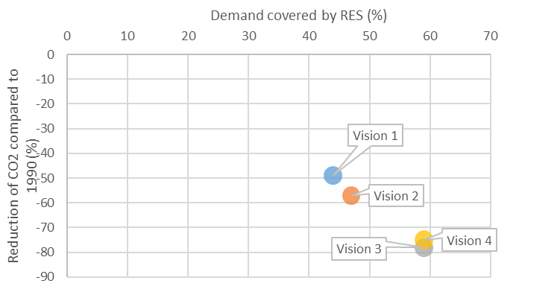

**Figure 1 All 2030 Visions matching the renewables objectives of the electricity system. Note that while in this figure V1-2 and V3-4 seem close, they show a strong differentiation in spatial distribution of generation.**

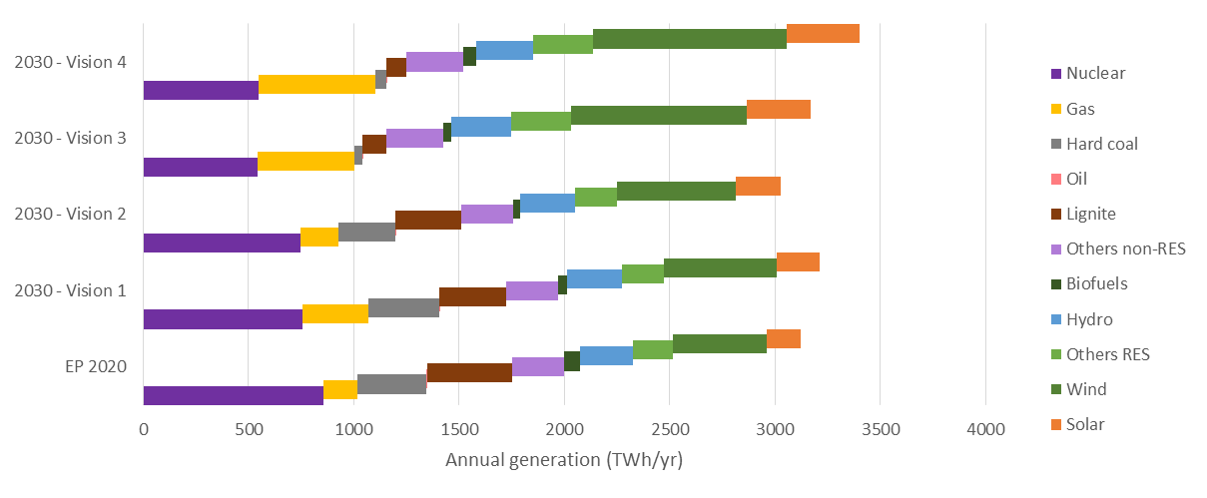

**Figure 2 Annual generation in each scenario – breakdown per technology class**

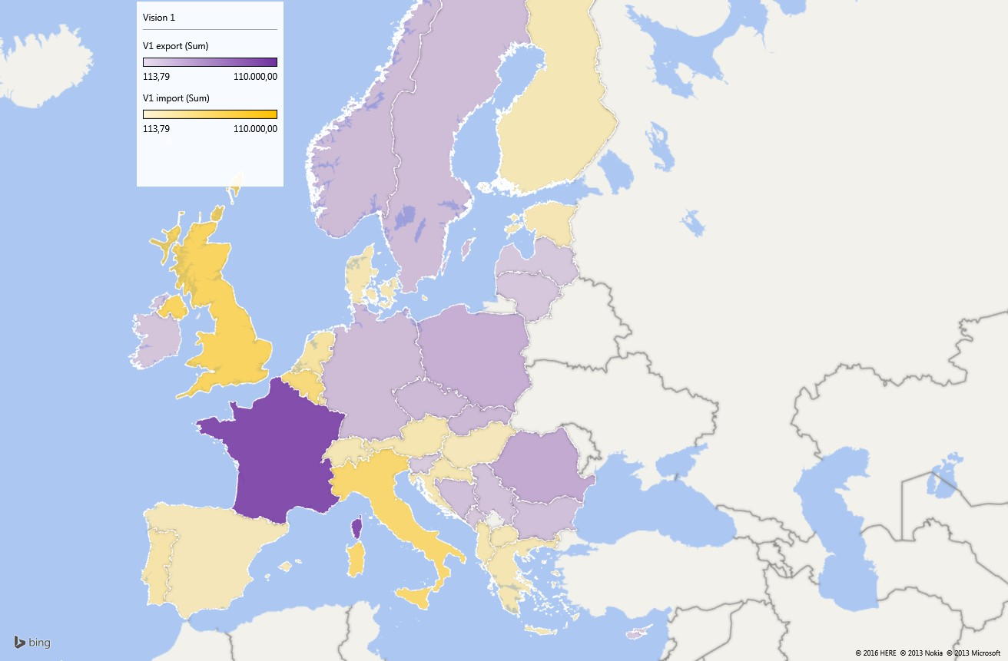   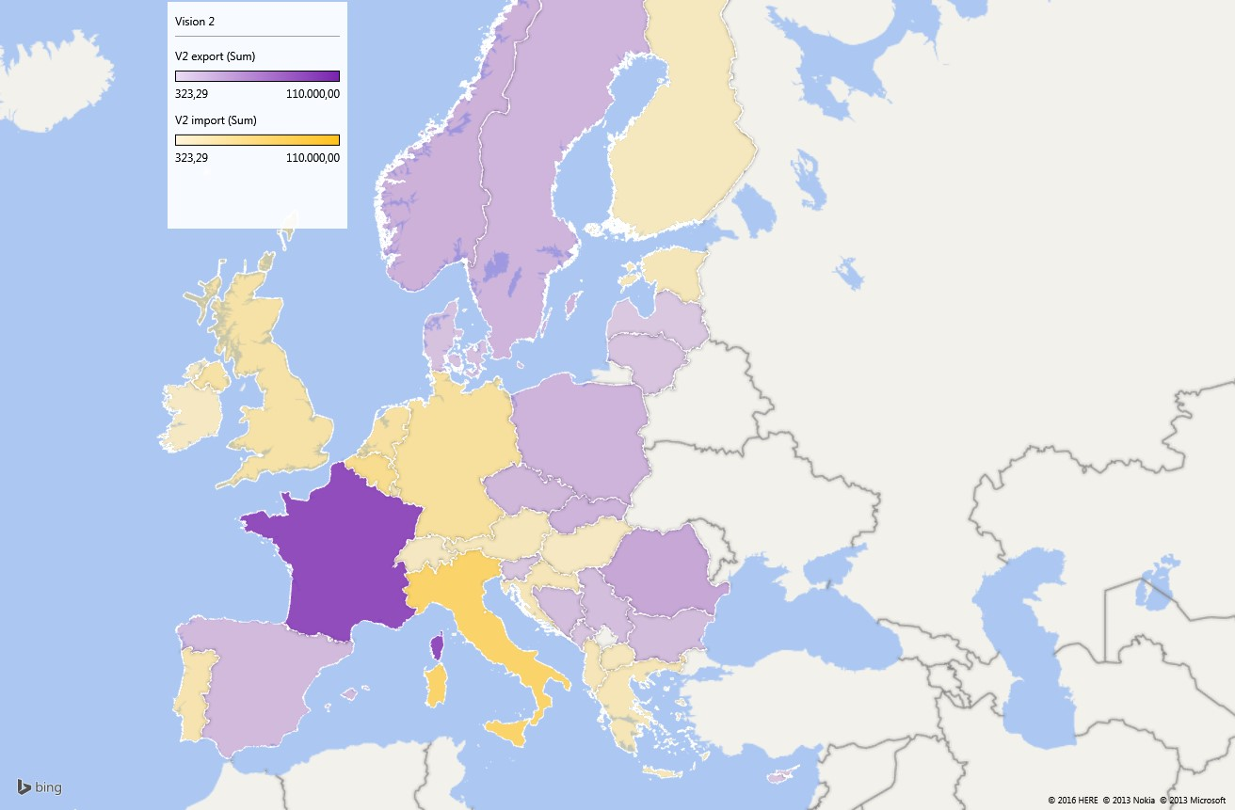   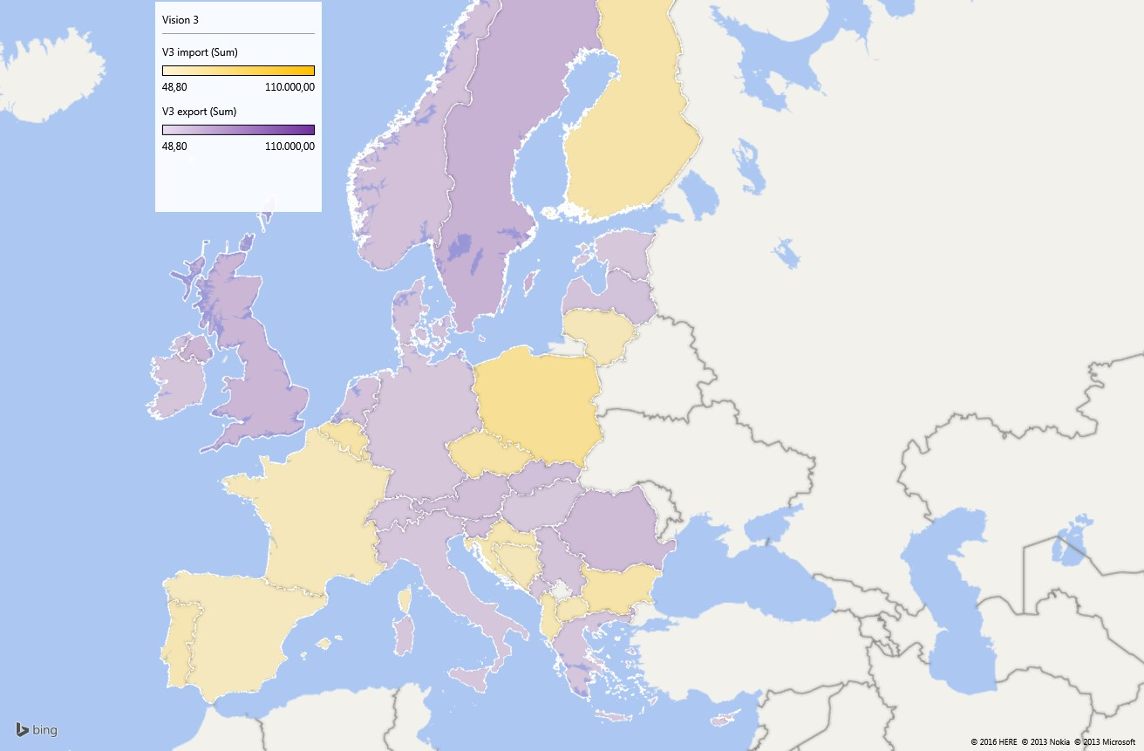   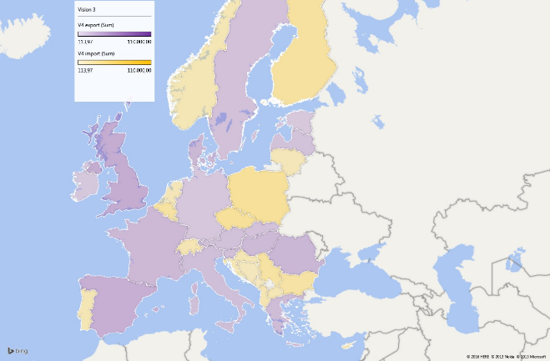

**Figure 3 - All visions show different views on which countries become importing or exporting on an annual basis. These differences are even more pronounced when looking at hourly flows. All this impacts the various TYNDP analyses of market integration, RES facilitation, and system reliability.**

# The TYNDP paves the way for the Energy Union

# 27% RES in Europe’s energy supply by 2030 means more grid

“We concluded that more transmission grid is needed to ensure RES development by 2030; and in this respect they prove relatively cheap, compared to generation and storage” (J. van de Putte, Greenpeace)

Variable RES uptake is the major driver for grid development by 2030. The generation fleet will experience a major shift in the next decade with the replacement of much of the existing capacities, probably located differently and further from load centres, and involving high RES development. This transformation of the generation infrastructure is the major challenge for the high voltage grid, which must be adapted accordingly.

Local smart grids will help increasing energy efficiency and improve local balance between generation and load. Nevertheless, ENTSO-E forecasts larger, more volatile power flows, over larger distance across Europe, mostly North-South driven by the aforementioned energy transition characterized by the increasing importance of RES development. The power flows are therefore very large in particular in the high-RES Visions 3 and 4.

Most transmission investments needs are linked to RES integration developments, either where direct connection of RES is at stake or because the network section or corridor is a bridge that links RES and load centres. In order to answer these investment needs, the TYNDP 2016 compiles €100 billion investments of pan-European significance, of which €60 billion is for projects already endorsed in national plans and/or intergovernmental agreements by 2030[^2]. The figures are in line with the previous analysis of the TYNDP 2014. This effort is significant for the financial means of TSOs. Still, it only represents about 1.5-2 €/MWh of power consumption in Europe over the 15-year period, i.e. about 2% of the bulk power prices or less than 1% of the total electricity bill.

This investment scheme has however a significant positive impact on the European social welfare. The created market integration will reduce bulk power prices by 1.5 to 5 €/MWh (depending on fuel and CO2 cost assumptions per scenario). This integration effect is also shown in about 40% avoided congestion-hours across all borders in the most conservative scenario.

In addition, it helps avoid 30 to 90 TWh[^3] of RES spillage globally, reducing it to less than 1% of the total supply. In the 50 to 80% of carbon emission reduction in the electricity sector by 2030 compared to 1990, up to 8% is enabled by the TYNDP infrastructure.

Investing in the project portfolio represents generally a payback for society after 20 years in a rather conservative scenario. The TYNDP 2016 thus confirms the main findings of the previous releases of the TYNDP. It also completes them in new respects by exploring and presenting additional elements.

**Footnotes:**

# Main barriers for power exchanges in Europe

“The stronger the RES development in large scale, the stronger the power flows and the transmission capacity needs from the periphery of Europe, with higher RES potential, towards its heart, where most of the load centres are”

(G. Sanchis, e-Highways 2050 project leader, Nov/15)

Past releases of the TYNDP used to pinpoint four “electric peninsulas” – namely Ireland and Great Britain, the Iberian Peninsula, Italy and the Baltic states – among a total of about 100 investment needs all across Europe. The TYNDP 2016 re-confirms needs. The presentation in this edition has been reshuffled in order to ease the 3rd PCI identification process in 2017. In view of the upcoming PCI selection process, it is necessary to guarantee a stable framework as well ([link](/insight-reports/getting-projects-built/)). Those projects already listed as PCI, and for which a final investment decision has been taken, require no further re-assessment.

This new presentation highlights the main “boundaries” in the European system where projects complete each other to develop the transfer capacity of one corridor; or, conversely, where projects compete with each other, should the target capacity be lower than the capacity delivered by all of them. Other investment needs of pan-European relevance have in most cases only one project at stake, but they can have in principle the same level of priority; even if they are also of high strategic relevance for the development of the infrastructure corridors, they can be reviewed in a simpler manner, independently from all others. The regional reports and project sheets in this TYNDP package give further insight in the relation between these boundaries, identified investment needs, and proposed priority investments.

The main boundaries are as many main barriers to power exchanges in Europe. They obey a globally radial pattern: tensions on the grid occur between regions of Europe, where potential for RES is high (hydro and wind in Scandinavia; wind in Scotland, Ireland, to Spain and Italy; solar in Mediterranean countries) and densely populated, power consuming areas in between. These barriers appear mostly where geography has set natural barriers: seas and mountain ranges, more difficult to cross.

## The ten main barriers for power exchanges, hence interconnection challenges, are:

* Wind development in Ireland and Great Britain will create high variations of power infeed on the two Islands, inviting to interconnect them together further (1), and the two with the Scandinavian hydro-storage (2) or to mainland Europe (3), which represents both a large outlet for surpluses or a source for back-up capacity conversely.
* Further interconnection of Nordic countries and their hydro-storage, with mainland Europe, especially to mitigate wind infeed variations along the North Sea (4) and Baltic Sea (5) coasts.
* Interconnection of the Baltic states to Europe (part of 5), in order to secure their supply from the West.
* East and South interconnection of Poland with Germany, Czech Republic and Slovakia (6), in order to increase market capacities.
* Interconnection of the Iberian Peninsula with mainland Europe (7), while providing appropriate synergies between the Spanish and Portuguese power systems, where most of solar potential in Europe lies as well as a significant wind potential .
* Further interconnection of Italy with its neighbouring countries: to link the Italian RES capacities and load with the Alpine hydro-storage on the North frontiers, and to connect the Italian system and main islands to the heart of the European market, to the Balkans and North African countries (8).
* Further interconnection of South-East Europe with Central Europe, to allow for mutual support (9) nowadays hindered by a low capacity.
* Further interconnection across the Balkan peninsula (10), taking advantage of the high RES potential in the East (e.g. Romanian wind, Greek solar) to supply load centres in the West, from Serbia through Montenegro to Italy.

There exists an eleventh boundary between the European ENTSO-E interconnected power system and its neighbours. **Europe could benefit from additional, cheap, generation surpluses at its outskirts, South and East**, and/or exchanging of RES generation in unbalancing situation. This would increase the need for stronger interconnection downstream, on the concerned boundaries mentioned above.

Regarding internal German boundaries, the analysis of TYNDP 2016 show that reinforcements of these do have large European benefits. The TYNDP 2016 therefore underlines the need for realizing the already planned internal German projects, which will resolve future internal bottlenecks. For status of these projects, see the project assessment sheets.

| No | Boundary | |-----|--------------------------------------| | 1 | Ireland - Great-Britain | | 2 | Norway and continent - Great-Britain | | 3 | Nordic - mainland West | | 4 | Nordic - mainland East | | 5 | Baltic states integration | | 6 | Central East integration | | 7 | Iberian peninsula integration | | 8 | Italian peninsula integration | | 9 | South-East integration | | 10 | Eastern Balkan border |

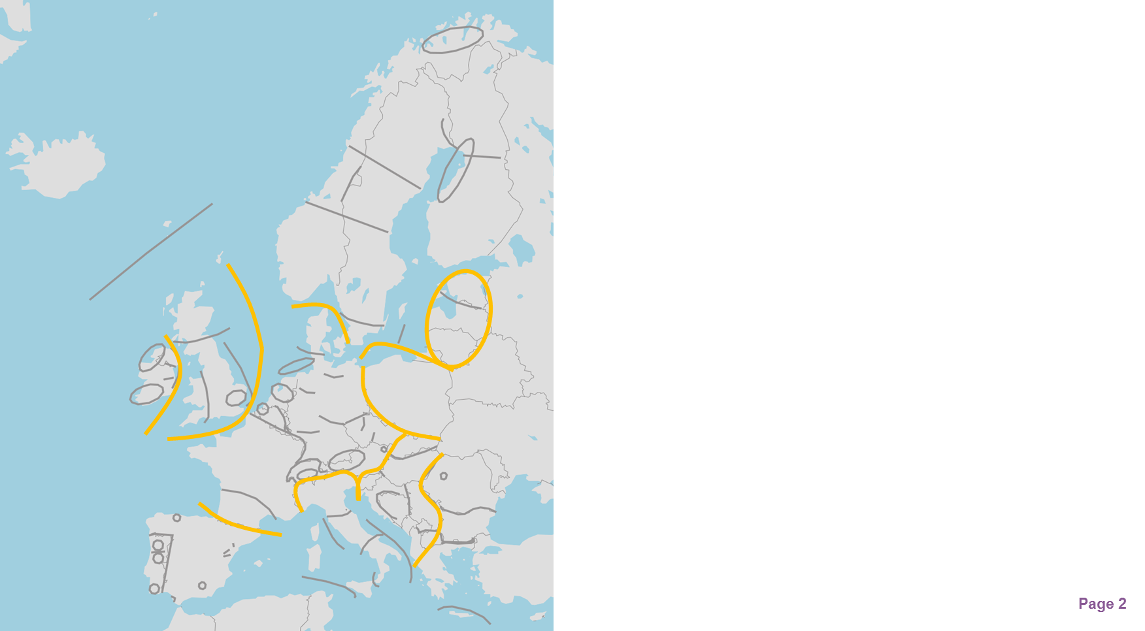

**Figure 3 Investment needs, and main boundaries and barriers**

The TYNDP project proposals address these 11 boundaries and barriers, as well as many more regional ones (see Figure 3). The TYNDP analyses give insight in the market/grid capacity enabled by these projects, as well sensitivities for these boundaries. The TYNDP project capacities added up **may be lower or greater than the target capacity that a well-integrated Internal Electricity Market would require**. As set forth in the Energy Union package, the optimal interconnection target capacity by 2030 shall “*take into account the cost aspects and the potential of commercial exchanges in the relevant regions*”. This is specifically what the Cost Benefit Analysis of the TYNDP deals with.

# 2030 targets for interconnection capacities

“Notes that Europe’s energy system has evolved ... in particular, renewable energy sources have been developed across the continent; recommends, in this context, that the 15 % target, based on installed capacity for 2030, should not stand alone, and that is should be assessed carefully and thoroughly to ensure that it is fit for purpose and is pertinent and feasible; asks ... to assess the setting of regional, complementary targets and to find better qualitative and quantitative benchmarks, such as trade flows, peak flows and bottlenecks, that highlight how much interconnection is needed." (European Parliament, ITRE, Dec/15)

Driven by RES development concentrated at a distance from load centres, and allowing for the required market integration, interconnection capacities should double by 2030 in Europe, on average. Discrepancies however, are high between the different countries and scenarios.

The proposed set of projects fulfils the 10% interconnection capacity goal (compared to the installed generation capacity for every Member State) by 2020, with one exception: Spain remains a critical concern in this respect, due to unique technical challenges in the area, and with reinforcement projects scheduled to be commissioned only by the middle of the next decade with enough political compromise.

For all four refined 2030 Visions, the TYNDP 2016 fine-tunes the interconnection target capacities for every border by 2030 reported in the TYNDP 2014, based on additional TSO coordinated studies (see figure opposite). The interconnection level is optimal in this analysis when the societal economic benefits brought by an additional project fail to overcome its costs. This principle however, is complex to implement in practice, and the approach here considered is a simplified one as only SEW is considered. In spring 2016, a dedicated Interconnection Targets Expert Group was set up by the EC in order to provide guidance and explain how accounting for trade flows and costs may make interconnection targets by 2030. The right order of magnitude for reinforcement cost figures are relatively easy to appraise for every border; the main difficulty is a comprehensive appraisal of benefits (strictly financial and others) of projects.

In particular, the present Cost Benefit Analysis methodology (CBA) is designed for “energy only” environment, where the generation mix is harmoniously developed, and captures operation cost savings in generation in a complete competitive market without considering market agent’s strategies to optimize their project portfolio revenues; it must however be completed by capital expenditures savings in back-up generation capacity, especially in a context of high RES development and another benefits that can be difficult to monetize. The “capacity” and “hedging” value of interconnectors can be significant for islands or peninsulas. It is however difficult to appraise and it is only mentioned as the comments to the CBA of the concerned projects, beyond the strict CBA requirements.

Therefore, the TYNDP 2016 can only provide an order of magnitude regarding the interconnection target capacity per border by 2030, with a narrow range depending on the Vision. But it also supplies transparently all computational bricks useful to support the 3rd PCI selection process in 2017. In particular, for every boundary, the relation between annual socio-economic benefits (SEW) is given as a function of the increasing capacity (GTC) and can be compared to the annuity of capex and opex of projects.

Such optimal interconnections targets ensure that the corresponding investment in transmission is profitable for Europe. The grid capacity will differ from one place to another, depending on the local environment. Even with such a reinforced grid, there will however remain congestions from time to time (because the additional market convergence benefit is too small to justify an additional investment). And most of the time, power exchanges will use only part of the interconnection capacity, while bulk prices in neighbouring price zones converge (and losses are reduced thanks to the extra capacity). In a well-integrated Internal Electricity Market, it is economically sound that the grid is sized so that the load factor of every grid element is lower than 50%, though it sounds like a paradox. This way though, the grid can at once cope with the volatility of power exchanges (with from time to time very strong flows) and meanwhile mitigate the induced losses (thanks to the extra capacity and hence a lower resistance).

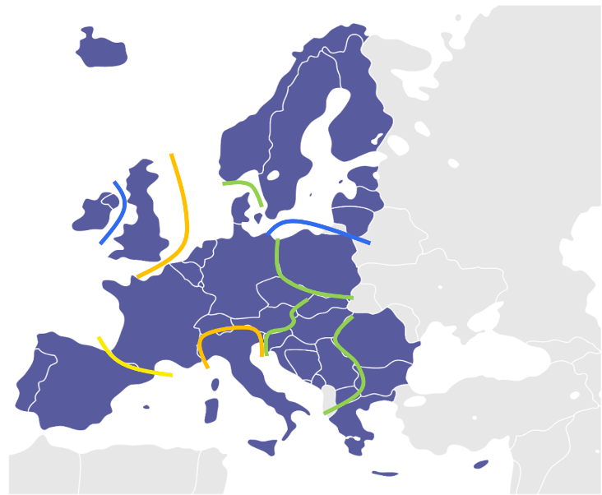

**Figure 5 – 2030 Vision 1 Target capacities**

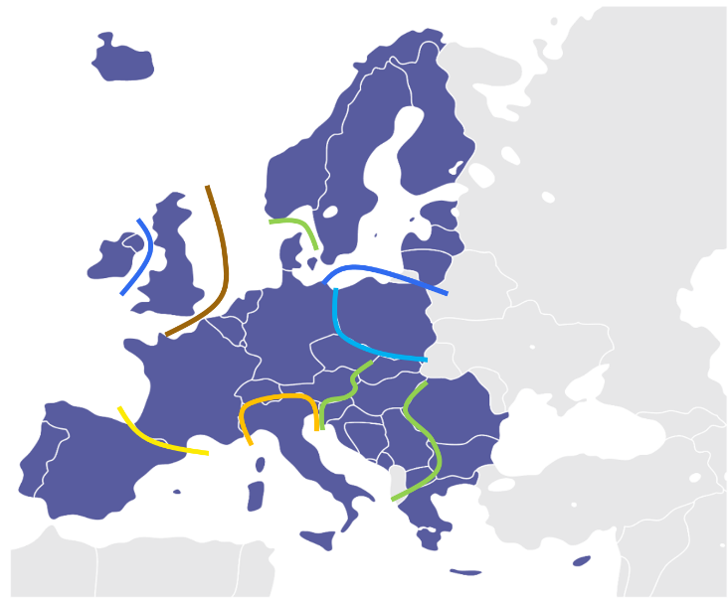

**Figure 6 – 2030 Vision 2 Target capacities**

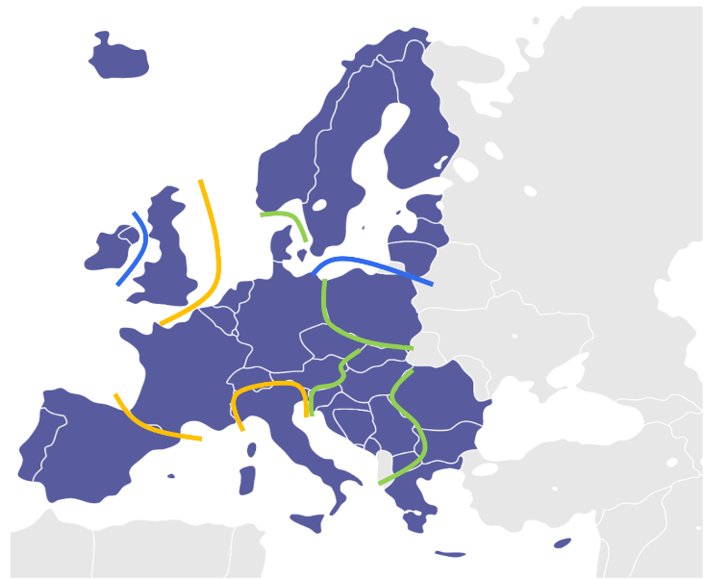

**Figure 7 – 2030 Vision 3 Target capacities**

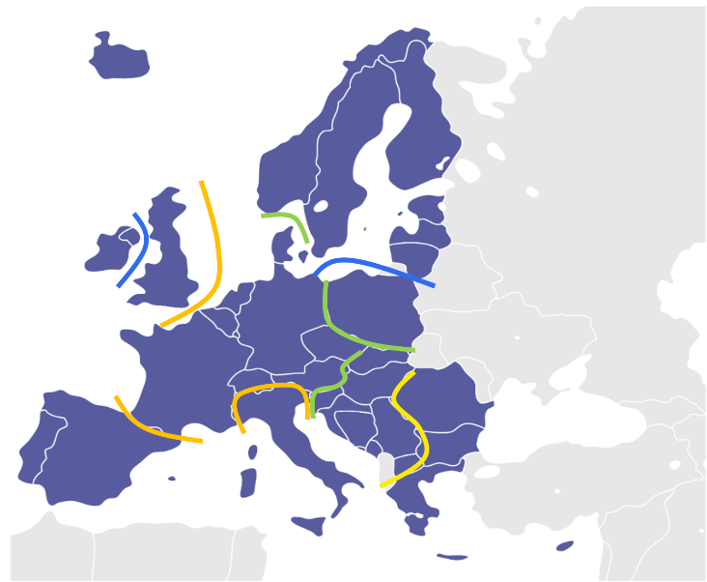

**Figure 8 – 2030 Vision 4 Target capacities**

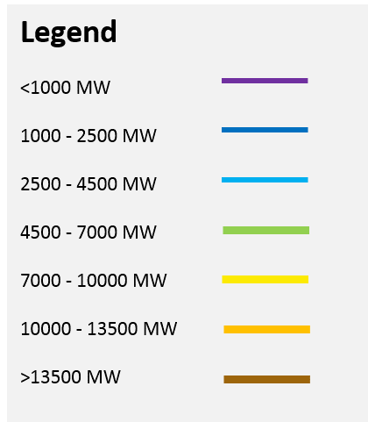

When comparing the four vision target capacities with the TYNDP grid capacities delivered (as assessed via the project CBAs), it gives a view on whether the TYNDP grid portfolio is adequate in all scenarios, part of the scenarios, or none at all.

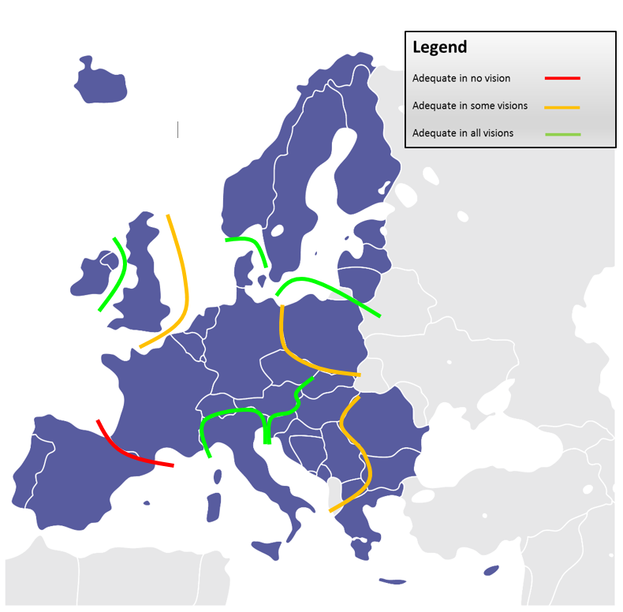

**Figure 9 – 2030 Transmission adequacy**

Still overall, TYNDP2016 market flow studies show that in the various 2030 scenarios the portfolio of mid-term and long-term grid infrastructure investments result in a reduction of over 40 % of the number of congestion hours. This shows the support TYNDP investments bring to a more integrated European energy market. Figure 4 also shows how the TYNDP portfolio reduces border average marginal price differences.), and ensure N-1 security (example give for Vision 3). The individual TYNDP project sheets also give further insight in how marginal price differences across borders fluctuate across the year.

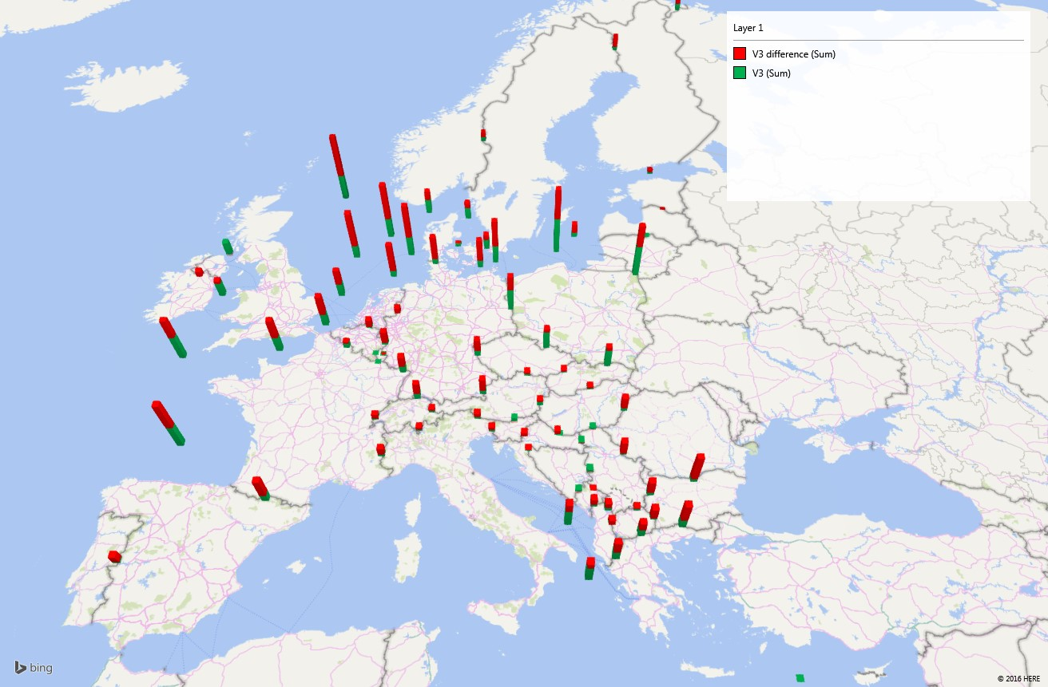

**Figure 4 - Reduction in yearly average of hourly marginal cost spreads in Vision 3, illustrating the benefit of TYNDP investments for European market integration. The total bar height represents the average price spread at each border in Vision 3 without the TYNDP investments; the green bars represent the remaining spread with the market capacity delivered by TYNDP investments.**

# A resilient portfolio of tailor-made investment solutions

The TYNDP provides a resilient picture of reinforcements on transmission grids, confirming in 2016 the TYNDP 2014 project portfolio. Some exceptions exist, mostly “concept projects” that were in a very early phase in 2014 that have proved technically unfeasible since. Still, the TYNDP2016 process has continued analysing several long-term scenarios and planning cases, and identified new TYNDP project proposals in the Regional Investment Plans 2015, mostly tagged as ‘future projects’ in the CBA analysis.

To come to that conclusion, thousands of market situations considering practically all hazards that may affect the power system have been simulated and processed for every scenario. Frequent situations or rare ones resulting in particularly extreme flow patterns (e.g. peak loads in winter or summer, with extreme but likely low or high wind/solar generation) are then spotted. The grid’s ability to withstand them is then tested, with possible remedial actions, and when these fail to solve the congestion pointing at investment needs.

The complete grid modelling enables an accurate appraisal of every bottleneck and allows the most appropriate solution to be designed. In order to solve investment needs, TSOs have proposed tailor-made grid reinforcement solutions adapted to every specific situation. As a result, a large range of available technologies is implemented.

For 15% of the cases, upgrade of existing overhead lines can prove sufficient to achieve the required capacity increase with a limited impact on crossed areas. Increased grid transfer capability does not always match with increased network length thanks to restructuring; and when the network length increases, it is by 40% underground or subsea.

Conversely, DC technology is required to cross seas. In certain situations, it is also implemented onshore or to transport large amounts of energy on new interconnection corridors. These new DC lines set new operating challenges that TSOs are investigating, be it to ensure the safe operation of parallel AC and DC assets or to coordinate and optimise the use of several DC links to create an offshore grid across the northern seas.

Project designs thus resort to cutting edge technologies. Some of them are demonstrators of new technology and world premieres: the largest DC VSC equipment, the longest subsea DC interconnector, the longest AC cable route, DC and AC parallel operation, etc. are all part of the European grid in coming years.

Aside from the proposed extra high voltage investments, TSOs also contribute to the development of smart grids: the latest electronic tools and IT systems help optimise the operation of existing assets and especially monitor, forecast and control distributed RES and load management. The implementation of Dynamic Line Rating also appears as a project of pan-European relevance in this TYNDP 2016.

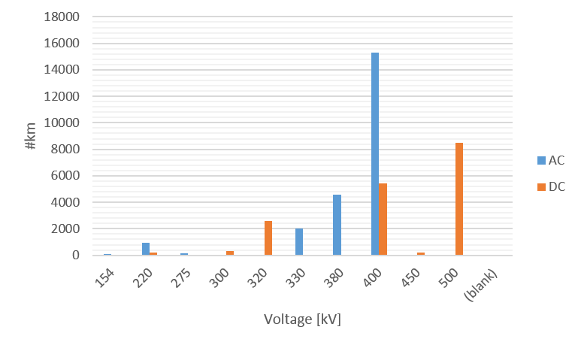

**Figure 9 – TYNDP 2016 project portfolio – breakdown per technology and voltage**

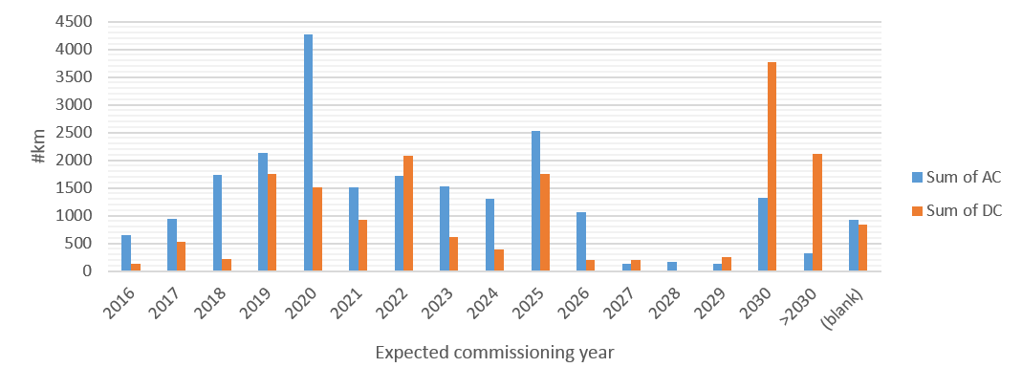

**Figure 10 – TYNDP 2016 project portfolio – breakdown per technology and year of commissioning**

| Type of element | Number of elements (total) | Number of elements (new) | |-------------------------------|----------------------------|--------------------------| | Overhead Line | 248 | 159 | | Phase Shift Transformer | 7 | 5 | | Subsea Cable | 49 | 45 | | Substation (incl. converters) | 57 | 33 | | Underground Cable | 15 | 15 |

**Table 1 Overview of main elements**

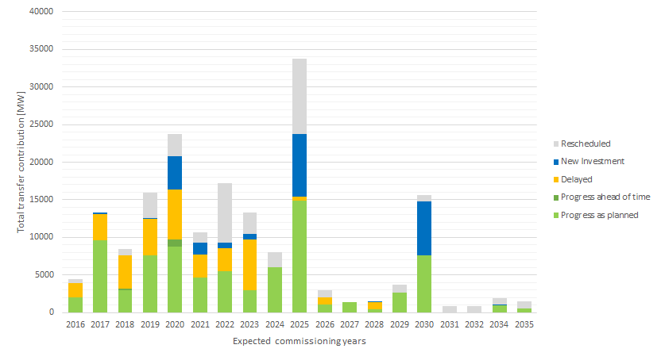

**Figure 11 - Additional grid transfer capacities introduced by TYNDP investments in the coming decades; with a note of the present (2016) status of these investments**

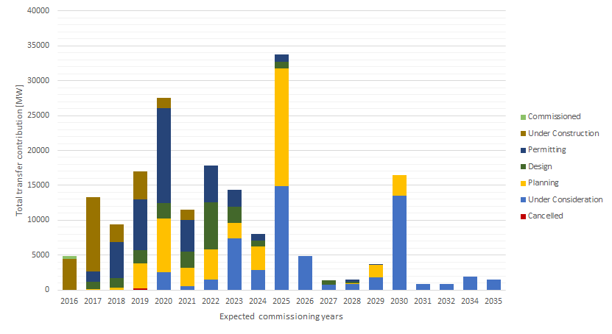

**Figure 12 - Additional grid transfer capacities introduced by TYNDP investments in the coming decades; with a note of the progress since 2014**

# A positive environmental impact

“Grids are the enabler of further renewable energy development, thus contributing significantly to the fight against climate change. I am an advocate for strong stakeholder cooperation on all levels of grid planning - from the TYNDP and PCIs to national grid development plans and local projects - because it does not only contribute to gaining public support, but also to the delivery of better projects for the environment.”

(A. Battaglini, RGI, Nov/15)

The project portfolio has **a positive environmental impact**. The grid has an indirect, but essential positive effect on CO2 emissions as it is a prerequisite to the implementation of clean generation technologies. By either directly connecting RES, avoiding spillage or enabling more climate friendly units to run, the project portfolio contributes directly to up to 8% of the CO2 decrease by 2030, and indirectly drives decarbonisation by facilitating RES connection in an integrated European market.

Grid extensions foreseen in this plan represent an increase in the **total network length of less than 1%/yr.** The figure is relatively low, but a must to accommodate **the 1% to 2.5%/yr installed generation capacity growth rate** (depending on the scenario), on top of a transition of the existing fleet. Moreover, one third of the new grid asset lengths are subsea cables, and 15% are upgrades of existing equipment. TSOs optimise the routes in order to avoid interferences with urbanised or protected areas as much as possible. In densely populated countries or where a significant share of the land is protected such as Belgium or Germany, this is a challenge. As a result, **less than 4% (resp. 8%) of the total routes of TYNDP projects cross urbanised (resp. protected) areas**, i.e. less than 2000 km (resp. 4000 km).

**Transmission losses are not expected to vary significantly** in the coming 15 years with the implementation of the plan as multiple effects will neutralise each other. On the one hand, building new transmission facilities or shifting voltage levels upwards reduces the overall electrical resistance of the network; on the other hand, the relocation of generation facilities further from load centres, specifically for wind or hydro energy, increases the transmission distance and system losses. HVDC interconnectors on average (and especially for long distance projects) have a more substantial loss increase as compared to other TYNDP projects.

**Projects of pan-European significance are hence key to make an energy transition in Europe possible,** with positive impact on the environment and minimum residual effect.

The energy transition is hindered by project commissioning delays. With still long authorisation procedures, completing grid development in time for RES integration is a challenge.

A key issue is to make the most complete information possible about transmission projects as easy as possible to access to European citizens that are directly affected by the construction of new lines, in order to foster buy-in for the new infrastructure and political support. In this respect, based on the suggestion of the Network Development Stakeholders Group, the TYNDP 2016 shall provide in every project assessment sheet, on top of the environmental indicators of the CBA, a map depicting the project route and the main sensitive (protected or urbanised) areas. Besides, links to complementary information available locally (in national language) are already provided when available, in order to make the project assessment sheet also useful for local consultation beyond PCI selection.

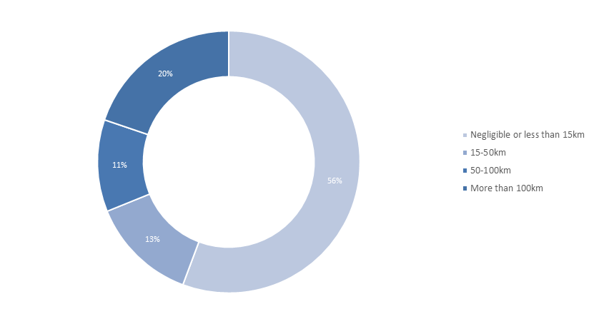

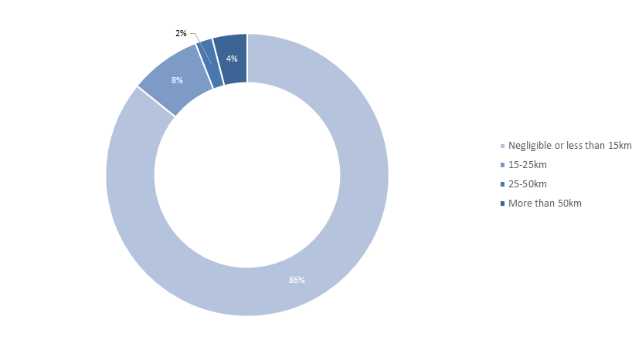

**Figure 13 Breakdown of projects depending on their length across sensitive areas (top chart: crossing environmentally protected areas; bottom chart: crossing dense urban areas)**

# Energy transition requires grid, grid requires everyone’s support

“The PCI label will sound great to a banker’s ear… if it was granted for a longer and stable period of time”

(P. Bernard, Friends of the Supergrid, Jun/15)

The TYNDP 2016 unfortunately confirms the trend identified in the previous TYNDPs, with moderate progress: about 25% of TYNDP investments suffered delays in past two years (compared to 33% in 2014), though more are being rescheduled (22% now compared to 12% in 2014). TYNDP monitoring also shows that of the TYNDP2014 investments in a design or permitting stage two years ago, at present 20% are under construction, and 5% has been commissioned. Making the comparison with TYNDP2012, these levels are respectively 30% and 10%. Implementation monitoring also shows that of the TYNDP2016 investments presently in design or permitting phase, on average these items have faced a delay of 1 year since 2014, and 3 years since 2012.

**The framework for Projects of Common Interest (PCIs) is promising** but is only beginning to generate its effect and taking momentum. It is still being implemented, with first annual feedbacks from EC to Members States about implementation and tuning. All OR most PCIs now in the authorisation process appear to meet the 3,5-year timeframe set for getting all authorisations. Still the alignment of national procedures for cross-border projects may require further harmonisation, as some authorisations may fall off the 3,5-year timeframe. Experience will show where inconsistency issues may require improvements in the future. It is also important to note that PCI best practices could be applied to national transmission projects which are crucial to the achievement of Europe’s targets for climate change, renewable energy and market integration.

Connecting Europe Facility, the European Bank for Investment and specific funds are ready to support project promoters. **Financing becomes less of a structural issue**, but can remain critical for some projects.

Still, **a stable regulatory framework** is essential to ensure grid reinforcement can be completed in time. In this respect, the PCI 2-year review could be improved by focusing, aside from new candidates, on PCIs affected by a change of consistency or commissioning date (or pre-defined additional conditions). In other words, a PCI would keep its label as long it stays on-track, securing the perspective of the concerned investors, which is the first key for success. In practice, PCIs post final investment decision (FID) would focus on construction, with a due reporting but sparing the resources needed for re-assessment.

The second key is to foster a better understanding of why’s and how’s of projects and **support from local citizens and politicians.** Some project promoters developed **innovative solutions** to bring the project local credit: dedicated citizens’ jury, national parliament’s support, holistic area development scheme along the project route, crowd-funding of transmission projects… Every solution today depends directly on the project background. They are also being further structured through R&D projects (e.g. Best path, Best grid), debated at conferences and may soon get maturity.

ENTSO-E hence welcomes the creation of the **Copenhagen Infrastructure Forum:** it will be a key tool to share experience, suggest improvements to the legal framework, and catalyse the implementation of innovative project management.

If energy and climate objectives are to be achieved, it is of utmost importance to get **political support on all levels.**

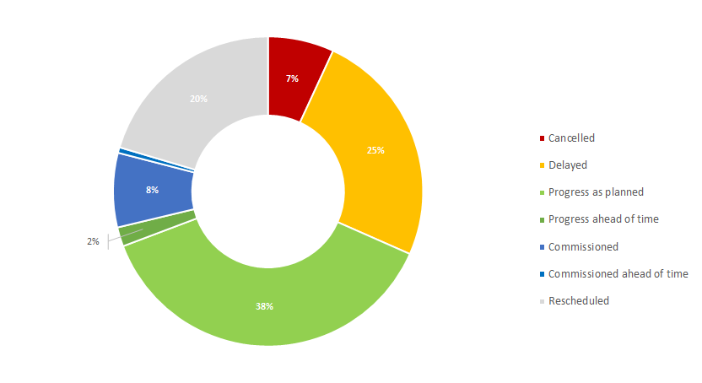

**Figure 15 Evolution of TYNDP 2014 project portfolio**

# 2030 system operation and market design are still to be invented

“The traditional assumption that grid inertia is sufficiently high […] is not valid for power systems with high RES shares […]. Frequency dynamics are faster in power systems with low rotational inertia, making frequency control and power system operation more challenging.”

(A. Ulbig et al, ETH Zürich, Apr/14)

45% RES generation by 2030 is a shift of paradigm for the power systems. Stronger interconnection will help Europe make the journey; it still leaves us with many issues to be addressed.

The volatility of RES infeed may result in steep variations of residual load. Added flexibility is required from all system components in operation: conventional generation units, as well as new Demand Side Response schemes or storage facilities. Appraising flexibility requirements falls beyond the possibility of the steady-state analyses of the TYNDP with 1-hour timeframe resolution. The dynamic system behaviour under severe contingencies (and especially the frequency stability) would require also complementary studies.

The TYNDP 2016 Visions assume that appropriate means to control frequency and voltage will simply be operational by 2030 (e.g IT devices on solar and wind units to simulate inertia to control frequency despite a lower involvement of conventional generation), in part by implementation of pan-European network codes for grid connection, operational guidelines, enhanced TSO/DSO interfaces, and technology progress. This is however a factor likely to challenge the consistency of the generation assumptions[^4].

Market simulations mimic an energy-only environment, where all generation means are assumed to be remunerated at the marginal market price. With RES penetration around 50% in the 2030 Visions, the energy-only market fails to pay back generation assets. A key underlying assumption in the TYNDP Visions is therefore that other mechanisms are at play to remunerate generation assets, such as subsidies, Capacity Remuneration Mechanisms or equivalent. This means the TYNDP 2016 studies analyse only one part of the total economic value of the power sector. Therefore the projects’ socio-economic benefits computed according to the Cost Benefit Analysis methodology appear under-estimated. This bias of the methodology is on the prudent side. This adds to other methodology assumptions which are already conservative: i.e. the marginal assessment compared to rather high reference capacity regardless of the commissioning time; or a set of less contrasting Visions; or a lower fuel and CO2 prices assumption compared to TYNDP 2014, making the 2030 bulk power flow prices ranging from 50 to 75 €/MWh.

Complementary aspects of many project (its “capacity” or “flexibility” value, e.g. linked to remaining average price differences and price difference standard deviations) are displayed in their project assessment sheet, to enable a complete profitability evaluation in the 3rd PCI list selection debates.

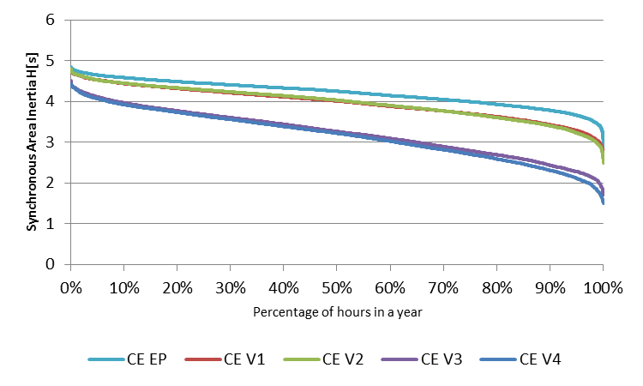   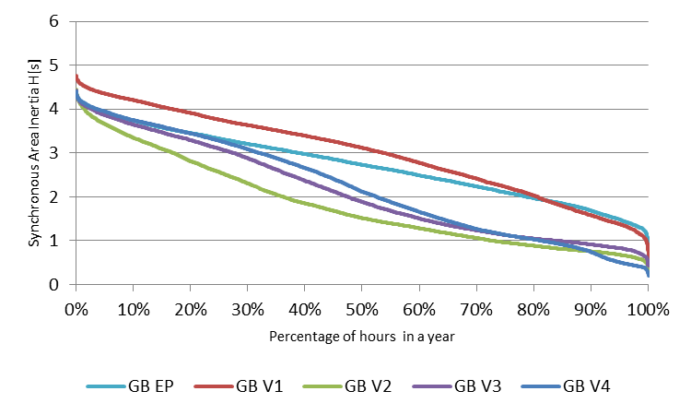

**Figure 16 Percentage of hours in a full year where estimated inertia is above a given value. Synchronous area equivalent inertia H[s] is calculated on the basis of online generators capacity. Examples of Continental Europe and Great Britain synchronous areas. EP2020 and 2030 Visions: V1 “Slowest Progress”; V2 “Constrained Progress”; V3 “National Green Transition”; V4 “European Green Revolution”**

From today’s situation towards 2030, as the connected capacity of RES increases, and as their contribution to the energy mix increases, the total inertia of the system will be reduced for extended periods of hours if no measures are implemented[^5]. Today’s situation is close to the 2020 views provided in above figures.

**Footnotes:**

# The TYNDP 2018 is already on the way

“What we assume today sets the frame under which the future is analysed. This is the reason why ENTSOG encourages all stakeholders interested in the future gas and electricity infrastructures and in scenario development to participate to ENTSOs scenario development process.”

(Jan Ingwersen, ENTSOG General Manager, 12.05.2016)

An international benchmark in 2015 showed that the European TYNDP stands unique world-wide in terms of number of TSOs collaborating, total number of customers served, methodologies to tackle long-term challenges, and transparency of data and process.

**Still, the TYNDP is a living object**, bound to evolve to meet stakeholders’ rising expectations. For instance, scenarios storylines will have to answer the still open questions about power system operation and profitability issues that are today answered in a too simplified manner; market modelling will also evolve consistently with raising concerns about security of supply or increasing DSR.

The feedback from the 3rd PCI list selection process in 2017 will also be essential.

The scope of the TYNDP 2018 can already be outlined. It has been discussed in the Network Development Stakeholders Group, and all stakeholders are invited to contribute to it in the consultations organised by ENTSO-E in 2016[^6]:

* The two ENTSOs join forces to propose a combined process (scenario building, milestones) to deliver their respective TYNDPs in two-year time. An interlinked gas and electricity modelling shall be finalised in 2016.
* The TYNDP shall more than ever focus on identifying longer-run pan-European relevance system needs (beyond ten-fifteen years).
* The TYNDP will also feed the PCI selection process, by supplying Cost Benefit Analysis of projects expected to be commissioned in the decade or so (hence focusing on five-ten years horizons).
* The scenario building starteds in May 2016, with a consultation on study horizons and scenarios outline. Recommendation from ACER and EC shall be complied with, especially the articulation with the Mid Term Adequacy forecast by 2025), and the reference to EU PRIMES scenarios for 2030. In order to maximise output and resources utilisation, ENTSO-E recommends to explore new 2040 scenarios and corresponding investment needs; and make projects CBA assessments for two mid-term study years (2025, 2030). The “Scenario development report” will be compiled and consulted first half of 2017.
* The identification of system needs would rely basically on pan-European market-studies (in order to derive target capacities, but also indicators about system inertia, ramps, adequacy issues, etc.), prolonged with regional analyses, in particular regional network studies (in order to characterise better every need, possibly analyse the evolution from ten-year to longer run horizons, and possibly propose reinforcement concepts). The “identification of system needs” package (one pan-European report and regional investment plans reports) shall be compiled and consulted end-2017.
* The Cost Benefit Analysis is updated in 2016, with a first draft put in consultation by ENTSO-E in Spring and will be submitted to ACER and EC later for validation and implementation for the TYNDP 2018.
* The TYNDP 2016 experience shows that the list of projects and target capacities by 2030 are stable enough so that the reference grid, compared to which CBA will be performed. Subject to the dedicated EC guidelines, ENTSO-E proposes to organise two windows for project promoters to ask for TYNDP assessment, one in June 2017 (based on which the reference grid will be set up), and one in December 2017, before the end of the assessment phase in June 2018.

The next steps will be based on feedback received in order to make the TYNDP 2018 best suited for its time.

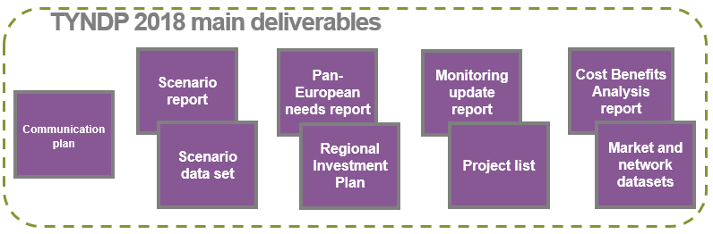   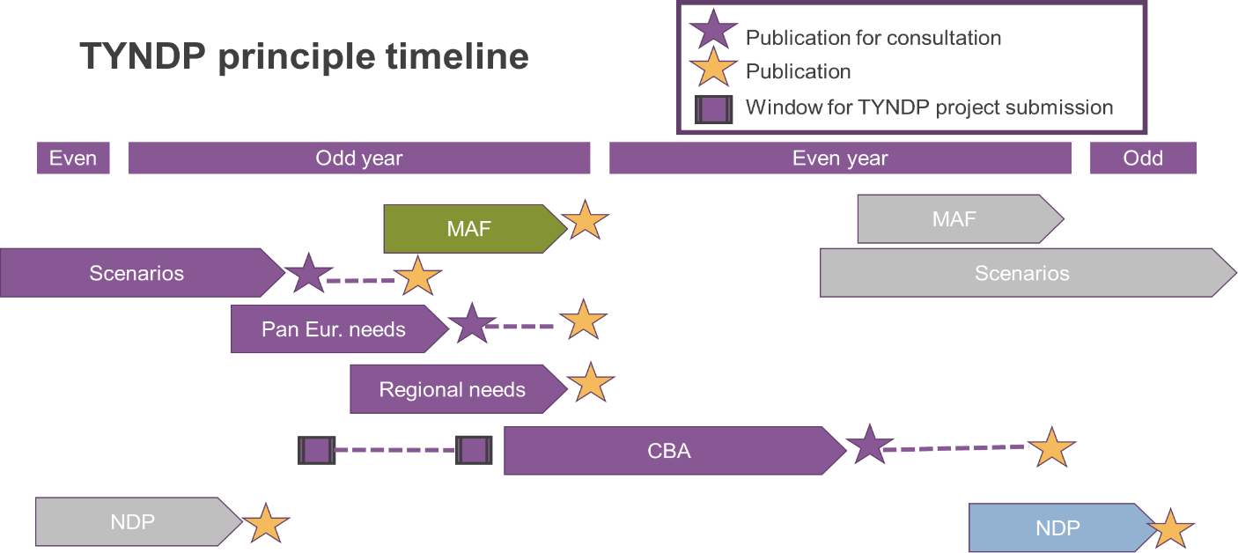   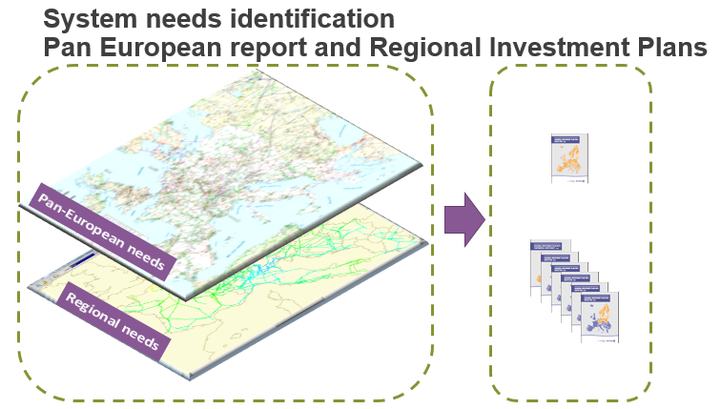

**Footnotes:**

# A new, updated and enriched TYNDP for electricity

“Make it more synthetic, easier to read, and all-in-one!” (practically, all surveyed TYNDP stakeholders)

Grid development is the core instrument in achieving the Energy Union goals. All Europeans aspire to more security of supply, affordable energy prices and sustainable development.

The 10-year network development plan (TYNDP) that ENTSO-E publishes every two year presents how to develop the power grid in the next fifteen years so that it can effectively contribute to achieving these different and sometimes competing goals.

The TYNDP is the outcome of a 2-year process, starting with the development of scenarios or visions of how the European power system might look in 2030. Over 200 experts Europe-wide carry out regional exploration studies, pan-European analyses and assess projects to reinforce the grid. The present publication complies with the requirements of Regulation (EC) 714/2009, whereby ENTSO-E shall adopt every two years a non-binding Community-wide 10-year network development plan, aimed at providing a vision of the extra-high voltage grid in 10-15 year time; and Regulation (EU) 347/2013, making the TYNDP the sole basis for the selection of Projects of Common interest (PCIs).

The TYNDP 2016 builds on the 2014 release, paving the way to the Energy Union 2030 goals set up in October 2014; accounting for the feedback received from stakeholders, especially DG ENER and ACER through consultations, public workshops, bilateral meetings and regular meeting of the Network Development Stakeholder Group (NDSG); and, on this basis, further improving methodologies and contents. Notwithstanding the usual analyses, from investment needs identification to transmission adequacy assessments, main improvements are:

* 5 scenarios are investigated, with four 2030 “Visions” comparable in main storyline to those of the TYNDP 2014 but refocused to the EU 2030 goals, updated with various evolutions, and designed with new methodologies; as well as a new 2020 “Expected Progress” scenario.
* Thanks to public dedicated workshops, the Cost Benefit Analysis (CBA) methodologies have been complemented with more transparent rules to define the reference grid for projects assessments.
* The TYNDP 2016 project list has been set throughout a public process from March to October 2016 under the aegis of the EC, and the active supervision of the NDSG, acting as ethical committee.
* The NDSG has also suggested making project assessment sheets more relevant to local communities, with maps of every project in its local environment and links to complementary national information.
* Project promoters have been invited to complete the ENTSO-E CBA results with their own information and comments to build self-supporting projects assessment sheets and better support the establishment of the 3rd PCI list.
* In addition, prior to investigating grid development issues, power system profitability and operational concerns by 2030 are analysed in a dedicated section of the report.

Although the TYNDP remains a heavy package in its entirety, every page or section is meant to be read stand-alone, and the reader is invited to browse the TYNDP webpage, flip through the reports and focus on the parts that trigger his or her interest.

**Footnotes:**

# Annex - TYNDP boundaries

* [Ireland - Great-Britain](./13-ie-gb.md)
* [Norway and continent - Great-Britain](./14-nordic-gb.md)
* [Nordic - mainland West](./15-nordic-west.md)
* [Nordic - mainland East](./16-nordic-east.md)
* [Baltic states integration](./17-baltic.md)
* [Central East integration](./18-cei.md)
* [Iberian peninsula integration](./19-iberian.md)
* [Italian peninsula integration](./20-italian.md)
* [South-East integration](./21-south-east.md)
* [Eastern Balkan border](./22-eastern-balkan.md)

# Ireland - Great-Britain

*Stronger interconnection of the Irish and Great Britain systems, taking account of an overall integration with Continental Europe and the Nordics.*

Two 500 MW HVDC interconnectors currently exist between both jurisdictions in Ireland (IE/NI) and GB. Numerous third party future projects are proposed for this border in TYNDP 2016; in general, these projects make use of potential renewable resources within the Island of Ireland to supply GB.

**TYNDP findings**

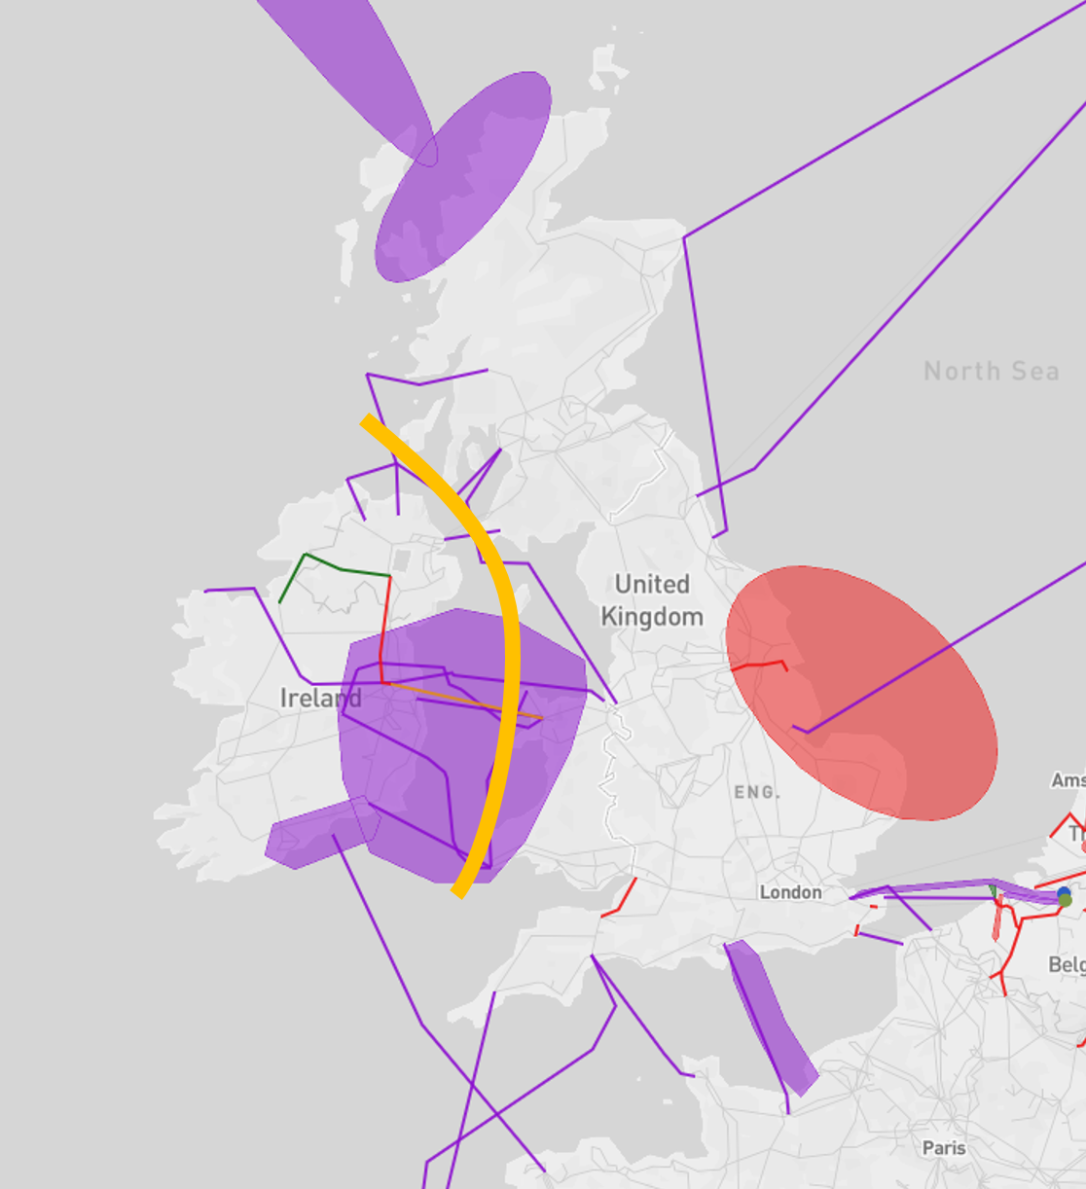

The analyses shows that projects across the Irish Channel have high benefits. Some of the proposed projects are additionally connected to wind energy production, exploiting related benefits.

**Welfare and Capacity**

The detailed TYNDP project CBAs show that the future projects typically provide SEW contributions of 20 – 50 MEuro/year, however, those projects which incorporate large quantities of additional renewable generation provide over 200 MEuro/year.

For nearly all Visions the energy balances between Ireland, the Republic of Ireland and Great Britain differ, leaving price differences between the three areas. These differences drive the SEW values. In Visions 1 and 2, Great Britain is an area of deficit, but an area of surplus in Visions 3 and 4. The Republic of Ireland is always an area of surplus, except in Vision 2, while Northern Ireland exhibits a similar pattern as Great Britain, but on different level.

**Interconnection target for 2030**

The large RES resource of the Island of Ireland, as well as potential large scale demand connections, could drive significant interconnection requirements into the future. The uncertainty over the generation portfolio and demand profile, as well as the lack of a Capacity Analysis curve, means that no definitive 2030 target is provided here.

# **Great-Britain – Continental Europe and Nordics**

*Linking the markets of Great Britain with Continental Europe and the Nordic region.*

The generation shift from coal to gas and from thermal to renewables is the main driver for increasing interconnection capacity between the different systems making up the North Sea region. Integrating the British system towards both the Continental and the hydro-based Nordic system, allows to benefit from the complementariness between their generation mix structures. Hence, developing new interconnections across this boundary is important to achieve the desired European market integration as well the integration of renewable energy, preparing for a power system with lower CO2-emissions for most of the Visions. Investments in the boundary play a key role in developing the Northern Seas Offshore Grid Infrastructure and will improve security of supply in the whole region, e.g. during times of low wind, high demand, dry years etc. Additionally, especially HVDC projects add flexibility to the systems due their controllability.

**TYNDP findings**

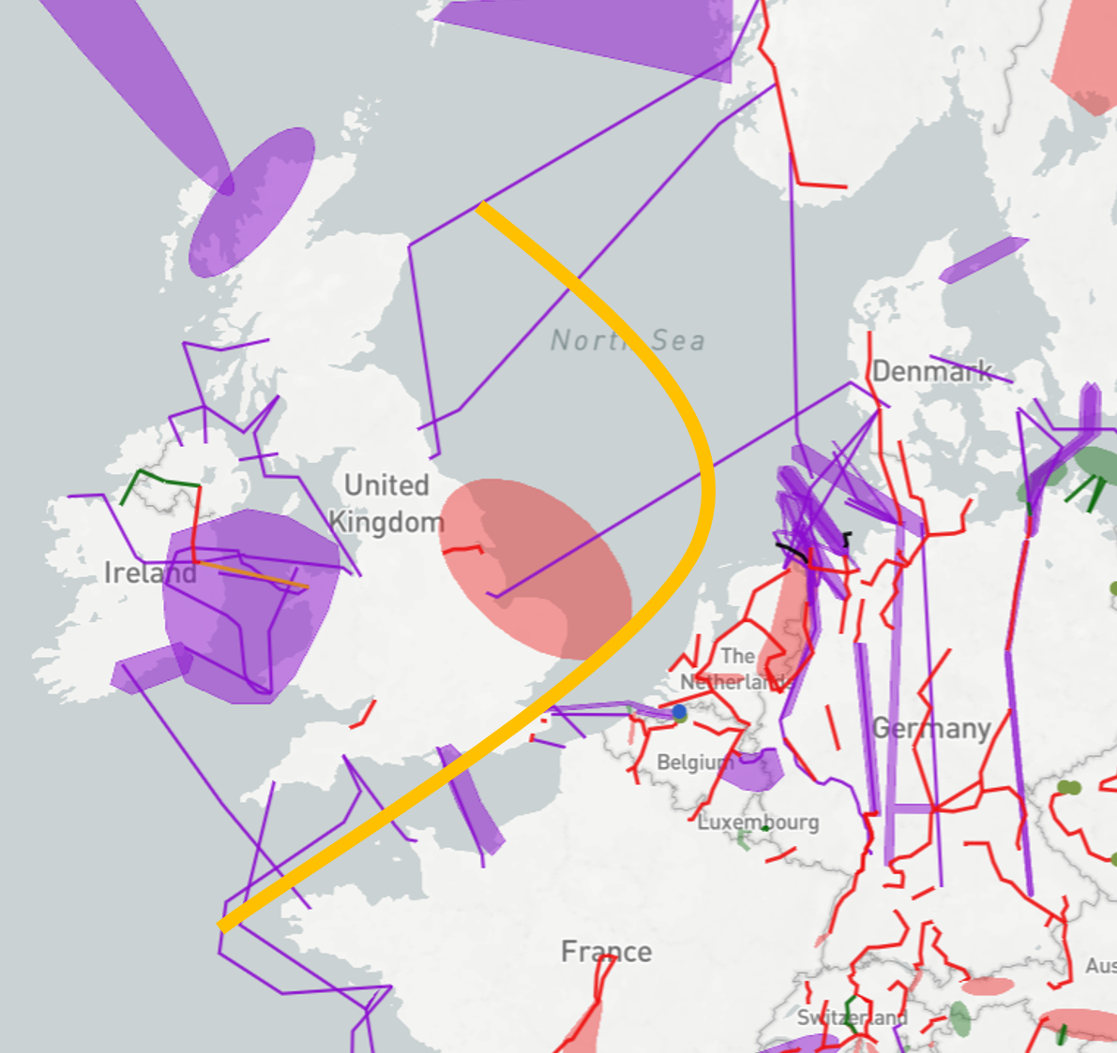

The analyses show that projects between the Nordic and the British systems do have high benefits, however also high costs due to the long distances. Between the Continental and the British systems, depending on the Vision, substantial price differences remain,.

In gas before coal market conditions, projects between the systems lead to decreased CO2-emissions. However, in visions with low CO2-prices where coal is cheaper than gas as e.g. in Vision 1, the projects may lead to an increased coal-fired production and subsequently increased CO2-emissions.

**Welfare and Capacity**

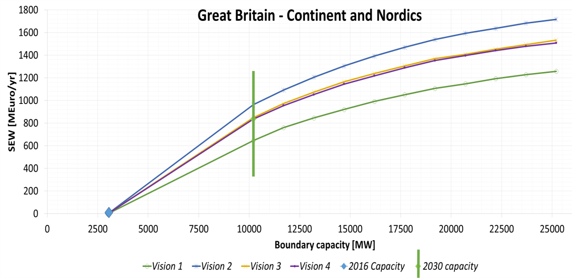

Market based capacity analysis performed in the TYNDP2016 shows a significant potential for increasing the capacity between the British, the Nordic and the Continental systems. At the same time, it is important to pay attention to the scenario assumptions. Bringing CO2, oil- , gas-, coal-prices down to 2016-level will influence the SEW-values in a negative direction. Having a look at the Socio-Economic Welfare (SEW) related to increasing boundary capacity, the values of the different visions indicates that the energy-balance is the main driver for price differences hence they drive the SEW-values.

Great Britain is a deficit area in Visions 1 and 2, less in Vision 2 than in Vision 1 given the higher amount of offshore wind, mainly importing from the Continent. In the more greener Visions 3 and 4 Great Britain turns into a surplus area, mainly exporting to the Continent.

Today’s capacity across the boundary is 3GW (blue dot), while the reference capacity of 2030, including all TYNDP16 mid-term and long-term projects, is about 10 GW (green vertical line). Projects not being part of the reference capacity, usually less mature projects or those being built beyond 2030 are indicated to the right hand side from the green vertical line.

**Interconnection target for 2030**

Making the balance between social welfare gain and infrastructure investment costs for higher levels of interconnection, the level of interconnection is above 10 GW for all Visions. The present and planned investments show that the reference capacity might be reached by 2030, even though this includes projects of more than 7 GW.

# **Nordics - Continental Europe West**

*Interconnecting the hydro-based Nordic system (NO/SE) with the thermal/nuclear/wind-based Continental system*

The main drivers for investments in this region are to integrate the hydro-based Nordic system with the thermal/nuclear/wind-based Continental system. This will improve security of supply both in Norway/Sweden in dry years as well as for the Continental system in periods with negative power balance (low wind, high demand etc.). Additionally the boundary is important both for the European market integration, facilitating renewable energy and preparing the power system with lower CO2-emission.

**TYNDP findings**

The analyses show, that projects between the Nordics and the Continental system do have a reasonable good socio-economical cost/benefit ratio. However, the values are very dependent of the basic price-assumptions (CO2, coal, gas) as well as the energy-balances in each system hence the price-differences between the systems.

In general, projects between the systems leads to decreased CO2-emissions. However, visions with low CO2-prices, may lead to increased coal-fired production and subsequently increase CO2-emissions.

**Welfare and Capacity**

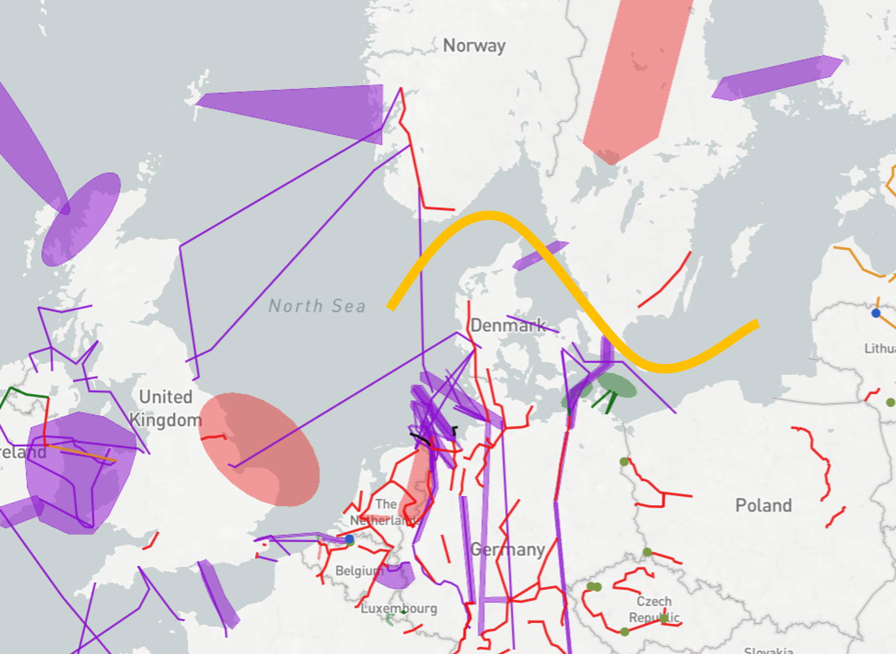

Market based capacity analysis performed in the TYNDP2016 show the potential for increasing the capacity between the Nordics and the Continental system. At the same time it is important to pay attention to the assumptions. Bringing CO2, oil-, gas-, coal-prices down to 2016-level will influence the SEW-values in a negative direction. Having a look at SEW/GTC-values of the different visions indicates that the energy-balance of the different visions both for the Nordics and Continental countries is the main driver for price differences in the visions hence they drive the SEW-value of connecting the Nordic and continental systems. The Nordic surplus is very high in Vision 2, which results in a high price difference and subsequent high SEW/GTC-value.

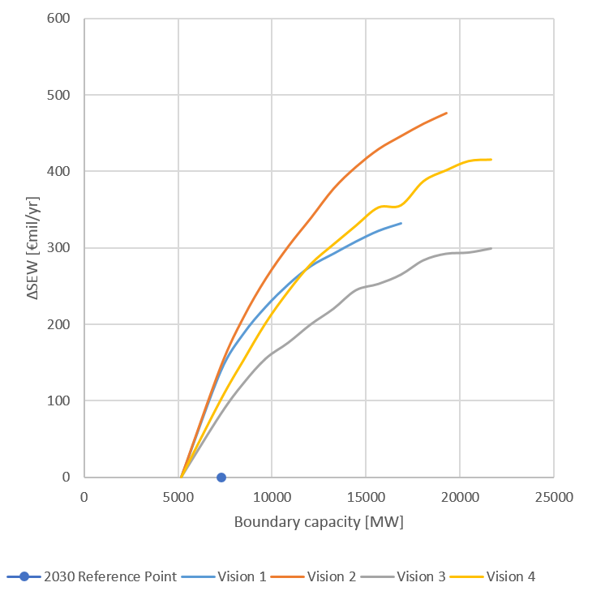

In general SEW-values for projects towards the Nordics are underestimated, this based on the fact that the studies only take into account an average hydrological year.

**Interconnection target for 2030**

Making the balance between social welfare gain and infrastructure investment costs for increasing levels of interconnection, the optimal level of interconnection ranges from 4,5 GW to 7 GW. The present and planned investments show that the target capacity will be reached by 2030.

# **Nordic/Baltic to Continental Europe East**

*Enhancing market flows between North and South.*

The driver for investments in this region is to decrease price-differences between the Nordics/Baltics and the Eastern part of the Continental system as well as decrease overall CO2-emissions.

**TYNDP findings**

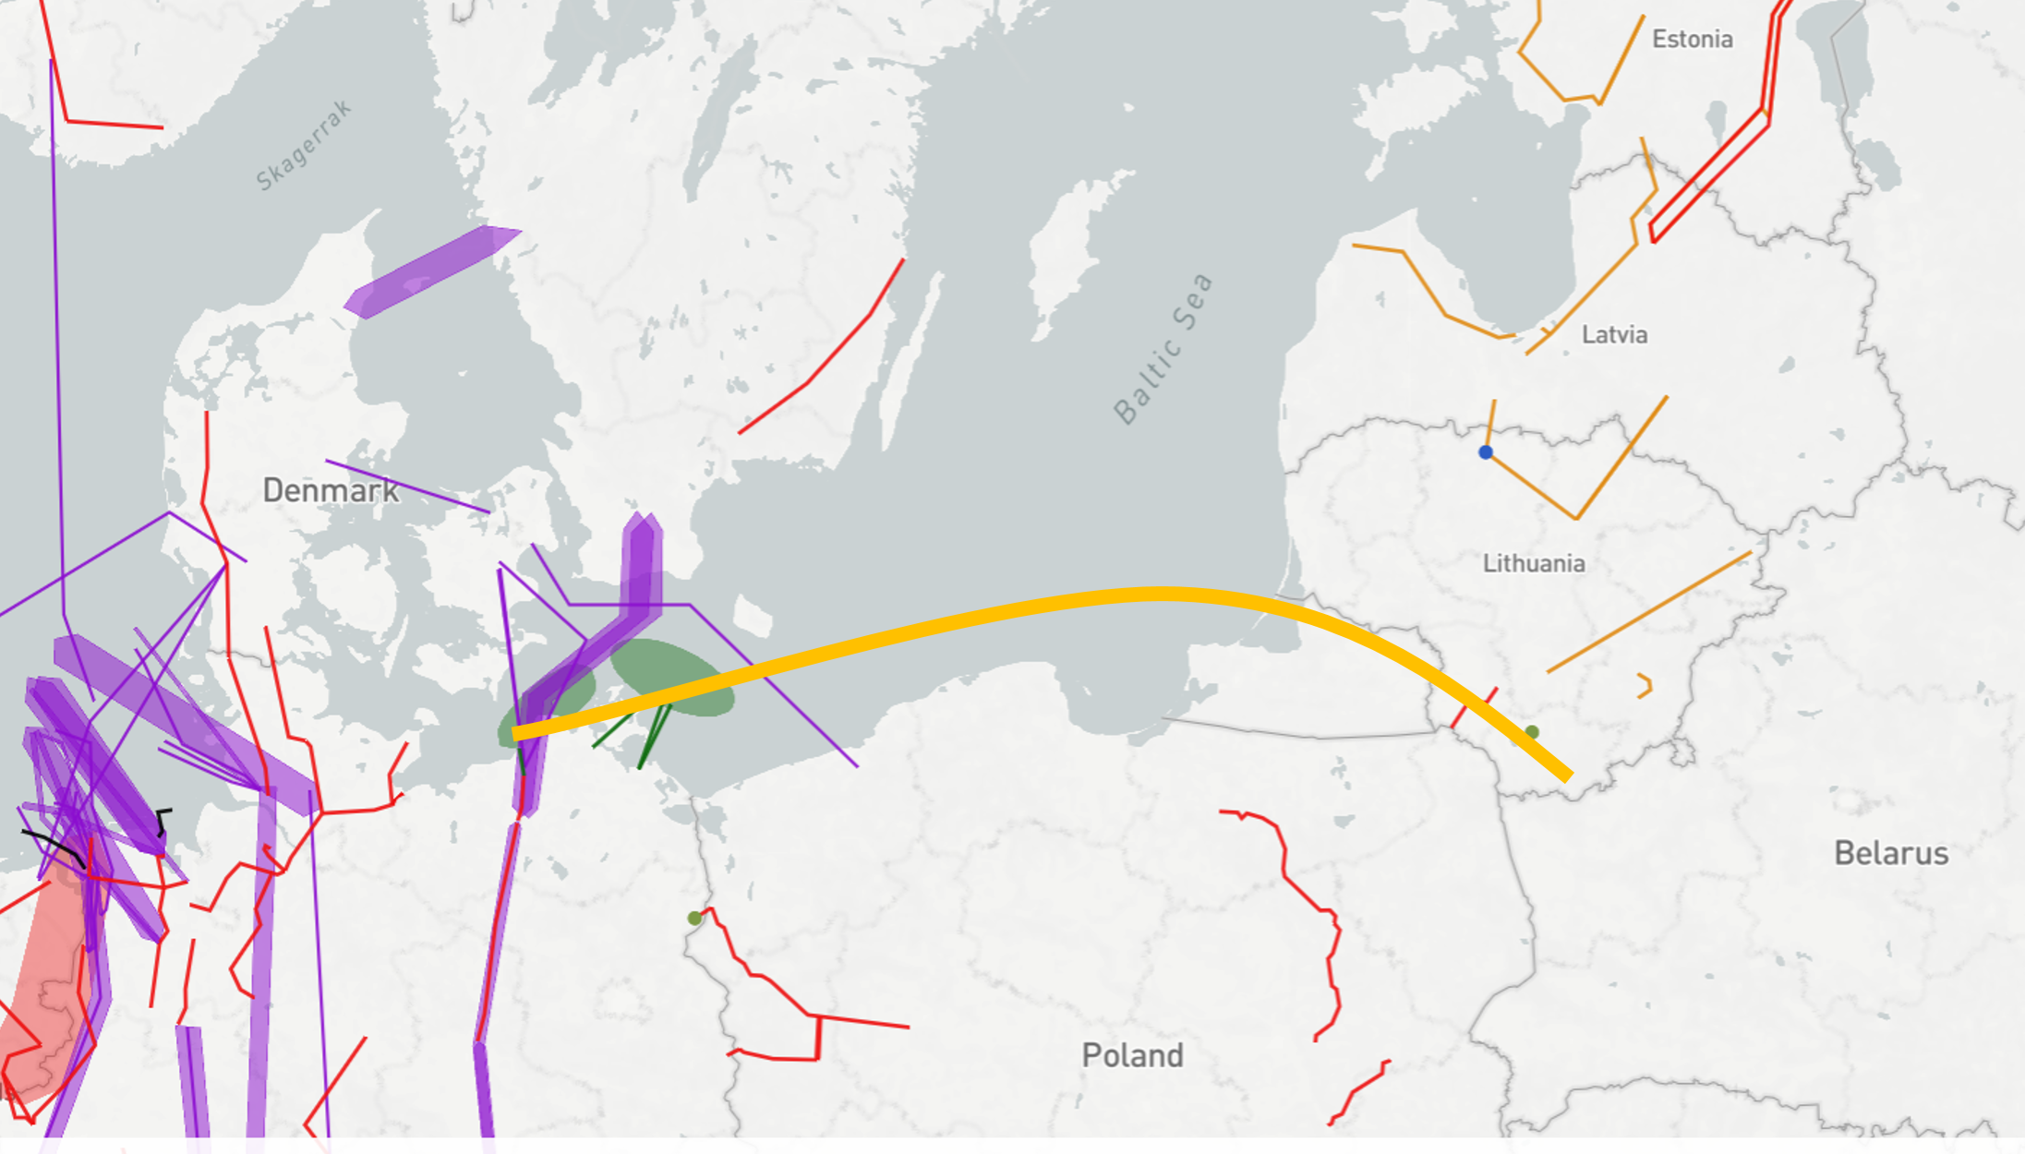

The analyses show a large potential for decreased CO2-emissions when integrating Nordics and Baltics towards Continental Europe East. However, the emissions are dependent on the visions. Low CO2-prices leads to increased coal-fired production hence increased emissions.

**Welfare and Capacity**

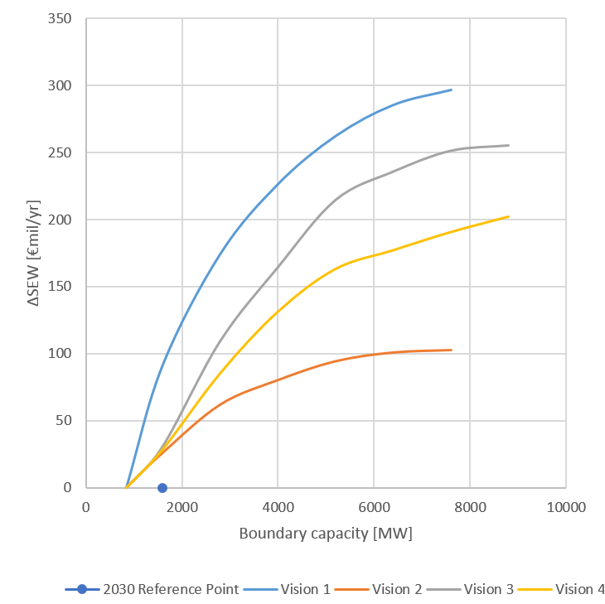

Detailed TYNDP project CBAs show that the average SEW contributions per project across this boundary range from 35 to 80 MEuro/year. This corresponds to about 50 MEuro/year per additional GW of transfer capacity.

**Interconnection target for 2030**

Making the balance between social welfare gain and infrastructure investment costs for increasing levels of interconnection, the optimal level of interconnection ranges from 1 GW to 2,5 GW between the Nordics/Baltics and the Continental Europe East. Compared to the present and planned investments this shows a potential for further projects.

# **Central East integration**

*Strengthening the grid in Central Eastern Europe between Germany, Czech, Slovakia and Poland.*

The driver for investments in this region is to decrease price-differences between the Poland and the neighbouring countries as well as increase security of supply.

**TYNDP findings**

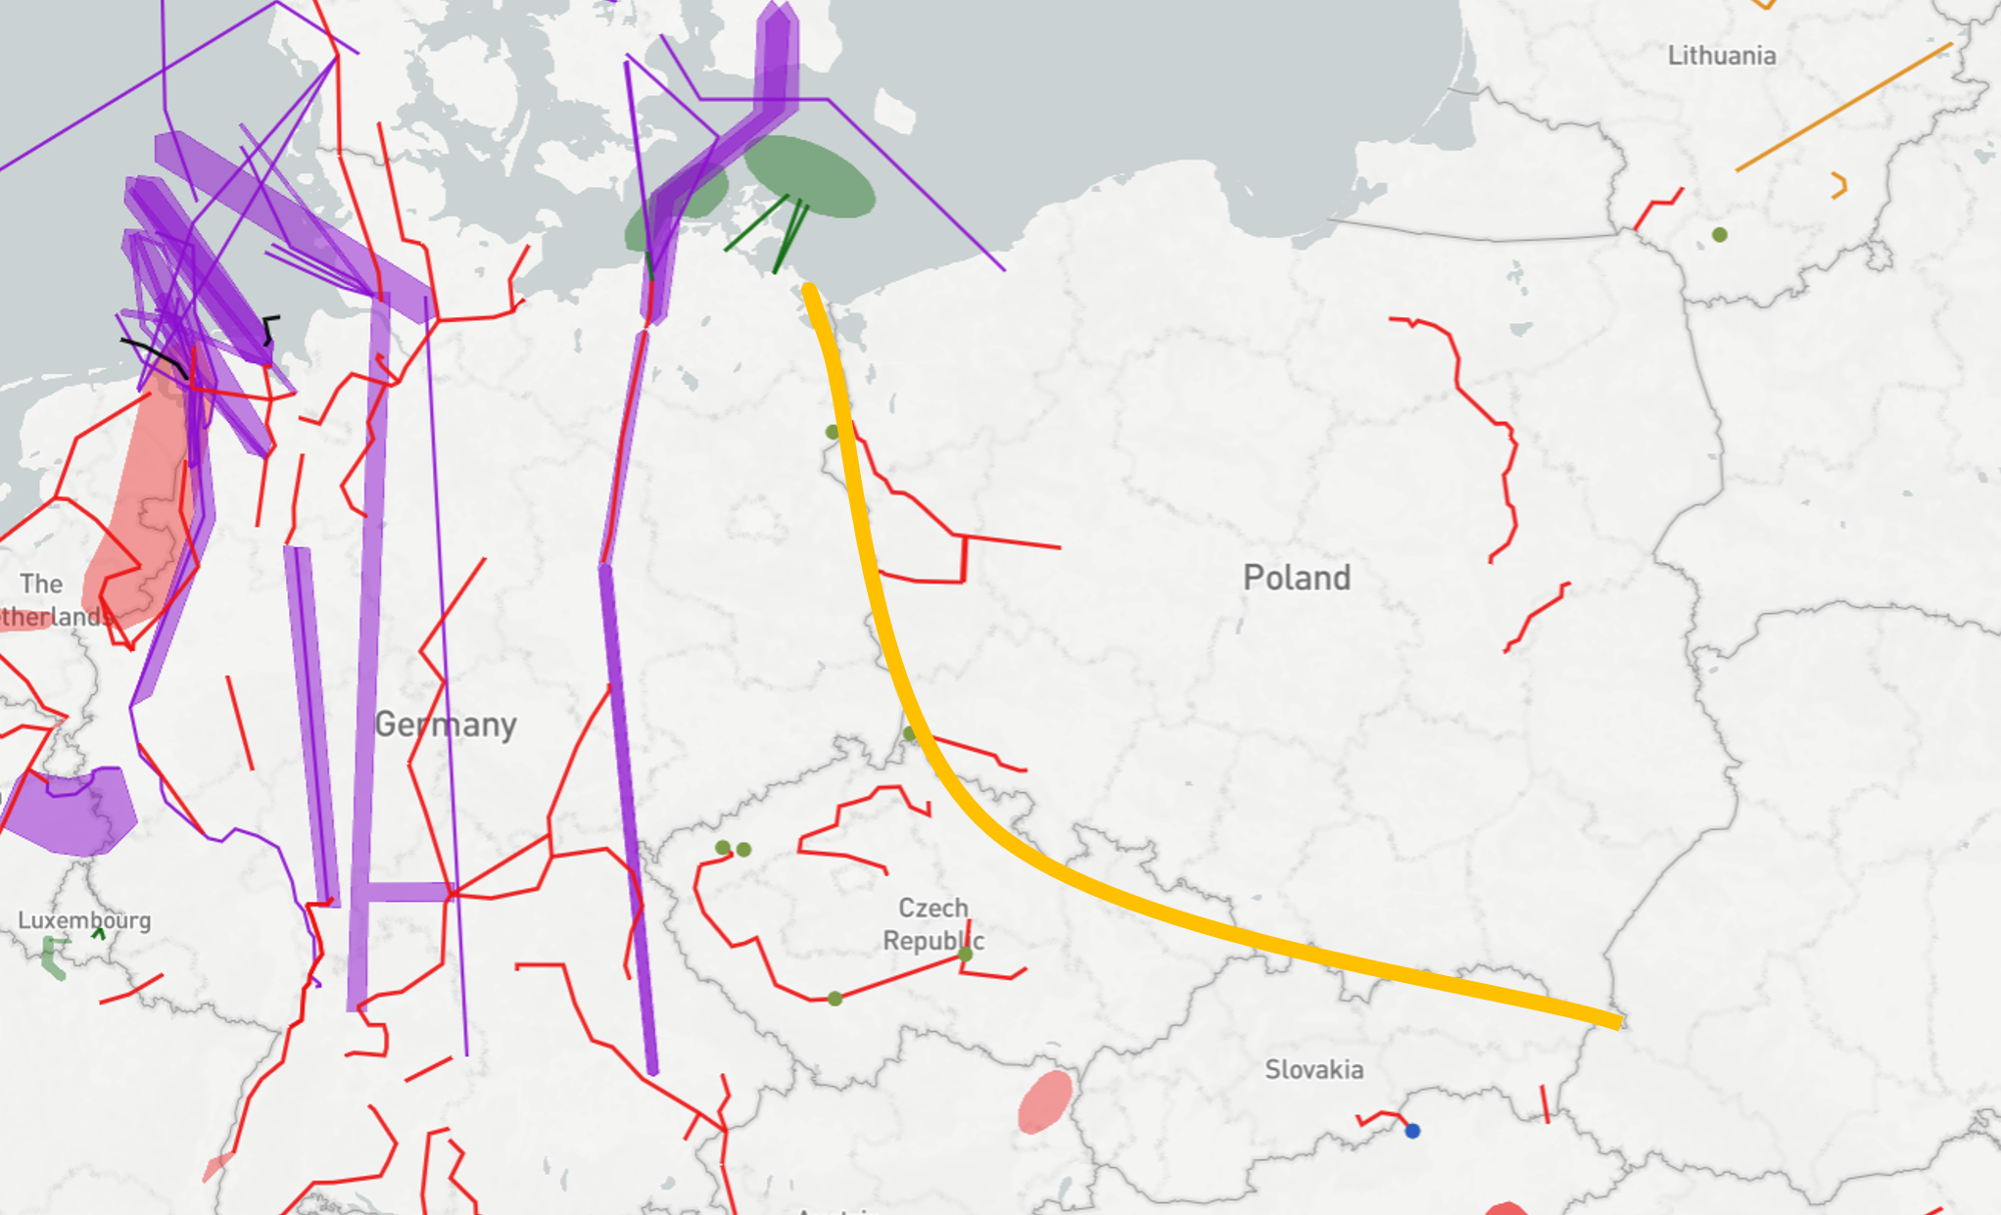

The analyses show that high dependency of prices in Poland are strictly relevant with CO2-prices. Self-sufficiency of Poland allow sustain on high level the security of supply at the expense of high energy prices. The emissions are dependent on the visions, where low CO2-prices leads to increased coal-fired production hence increased emissions. Implementation in Poland high efficiency coal technology allow decrease level of emissions significantly.

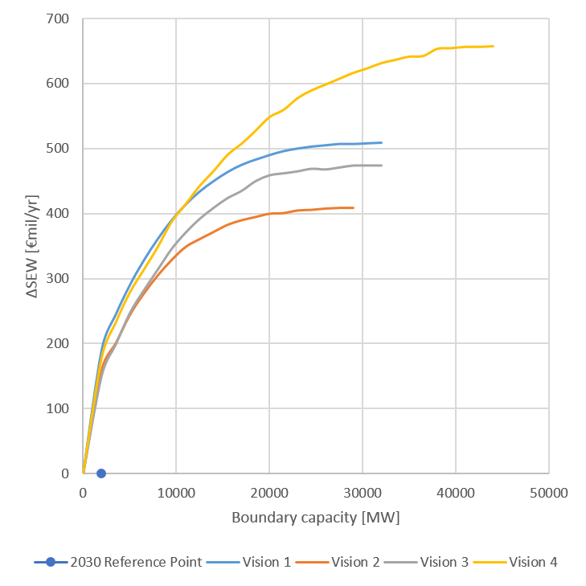

**Welfare and Capacity**

Detailed TYNDP project CBAs show that average SEW contributions per project in the perimeter of this boundary range from 40 to 82MEuro/year. This corresponds to about 95 MEuro/year per additional GW of transfer capacity.

**Interconnection target for 2030**

Making the balance between societal welfare gain and infrastructure investment costs for increasing levels of interconnection, the optimal level of interconnection ranges from 2,5 GW to 4,5 GW. Compared to the present and planned investments this shows a potential for further projects.

# **Iberian peninsula integration**

*Interconnecting the* *Iberian market (MIBEL)with the rest of Europe.*

**TYNDP findings**

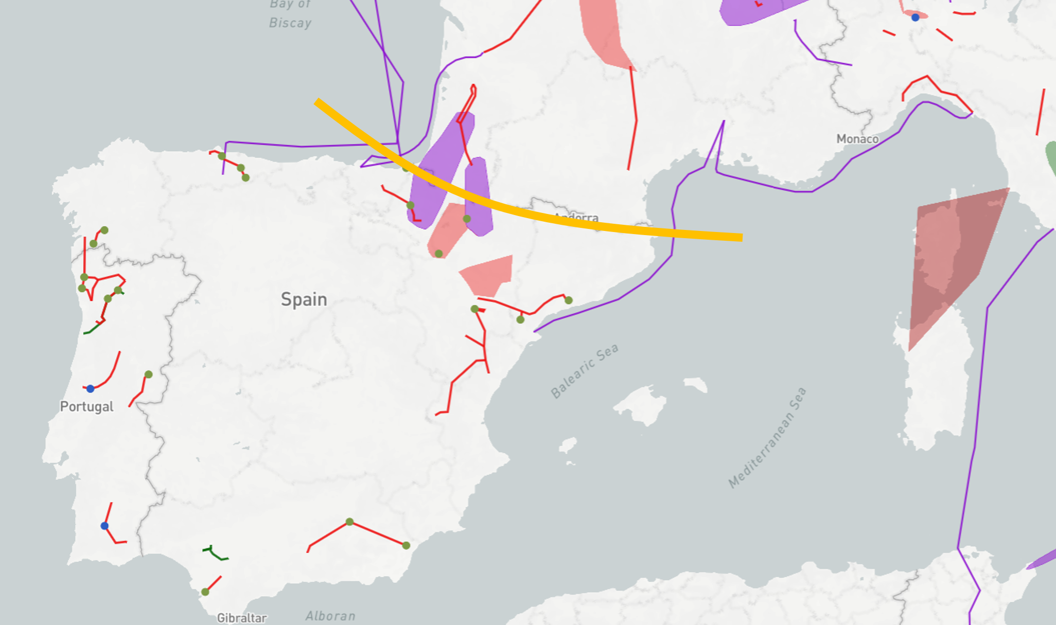

This boundary appears since many years as one of the most congested in Europe. Main drivers for grid development are i/the integration of MIBEL to European mainland market; ii/ RES integration, especially in the Iberian Peninsula; and iii/ the need for Spain to comply with the EU 10% interconnection rate target by 2020.

The Madrid Declaration signed in March 2015 by the EC and the French, Spanish and Portuguese Governments shows the strong political will to increase the capacity over this boundary by developing 4 projects (one PST, and three additional HVDC interconnections: one subsea and two terrestrial) on top of the HVDC already commissioned in 2015 on the eastern part of the border.

Three multi-terminal projects promoted by non-ENTSOE members are also assessed as future projects in TYNDP2016 although at the time of closure of the consultation phase these projects did not demonstrate compliance with the EC’s draft guidelines for treatment of all promoters; two of them would connect Spain, France and Great Britain and one Spain, France and Italy

**Welfare and Capacity**

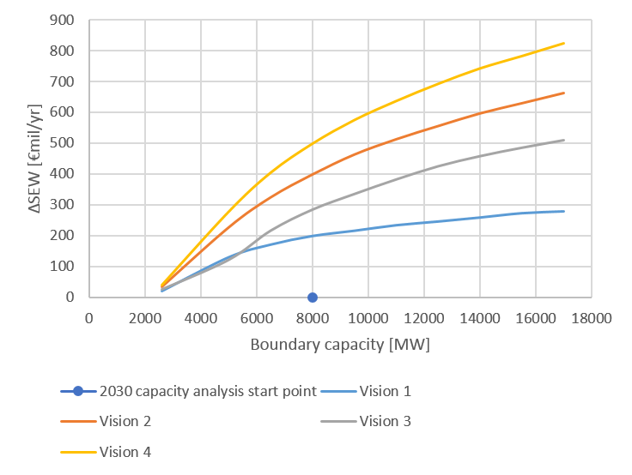

**Interconnection target for 2030**

Grid development through this boundary is driven by the compliance with the target interconnection rate of 10% of installed generation capacity for every EU country by 2020, as current ratio for Spain is still far from the target. Depending on the scenarios, the required capacity for 2030 ranges from 9 GW in Vision 1 to 15 GW in Vision 4.

The four projects mentioned in the Madrid Declaration are expected to increase the capacity between France and Spain to 8 GW and therefore this boundary is still marked as inadequate in all scenarios. Nevertheless this huge investment effort from TSOs improves very much the interconnection ratio of Spain (reaching around 9% in Visions 1 and 2 and around 8% and 6% in Visions 3 and 4 respectively).

Notwithstanding, looking at the particular geographical position of the region, if the Iberian Peninsula is considered as a whole (Spain and Portugal), the interconnection ratio would be lower.

# **Italian peninsula integration**

*Reinforcing the interconnection at the North-Italian boundary.*

The main drivers behind the development of the transmission capacity at the North-Italian boundary concern the exploitation of new generation, mainly located in the North of Germany and France (wind) and in the South of Italy (wind and photovoltaic). The interconnection projects planned on this boundary will enable wider power exchanges and, by this way, will make possible to integrate the above-mentioned generation and the pump storage capacity located in the Alps region. Furthermore, additional links between Italy and North-Africa and between Italy and Montenegro, will contribute as well to the interconnection of the Italian peninsula, by increasing market integration, RES usage and system security.  
In addition, the SA.CO.I 3 link connecting Italy and Corsica is of major relevance for the security of supply and market integration within the European system.

**TYNDP findings**

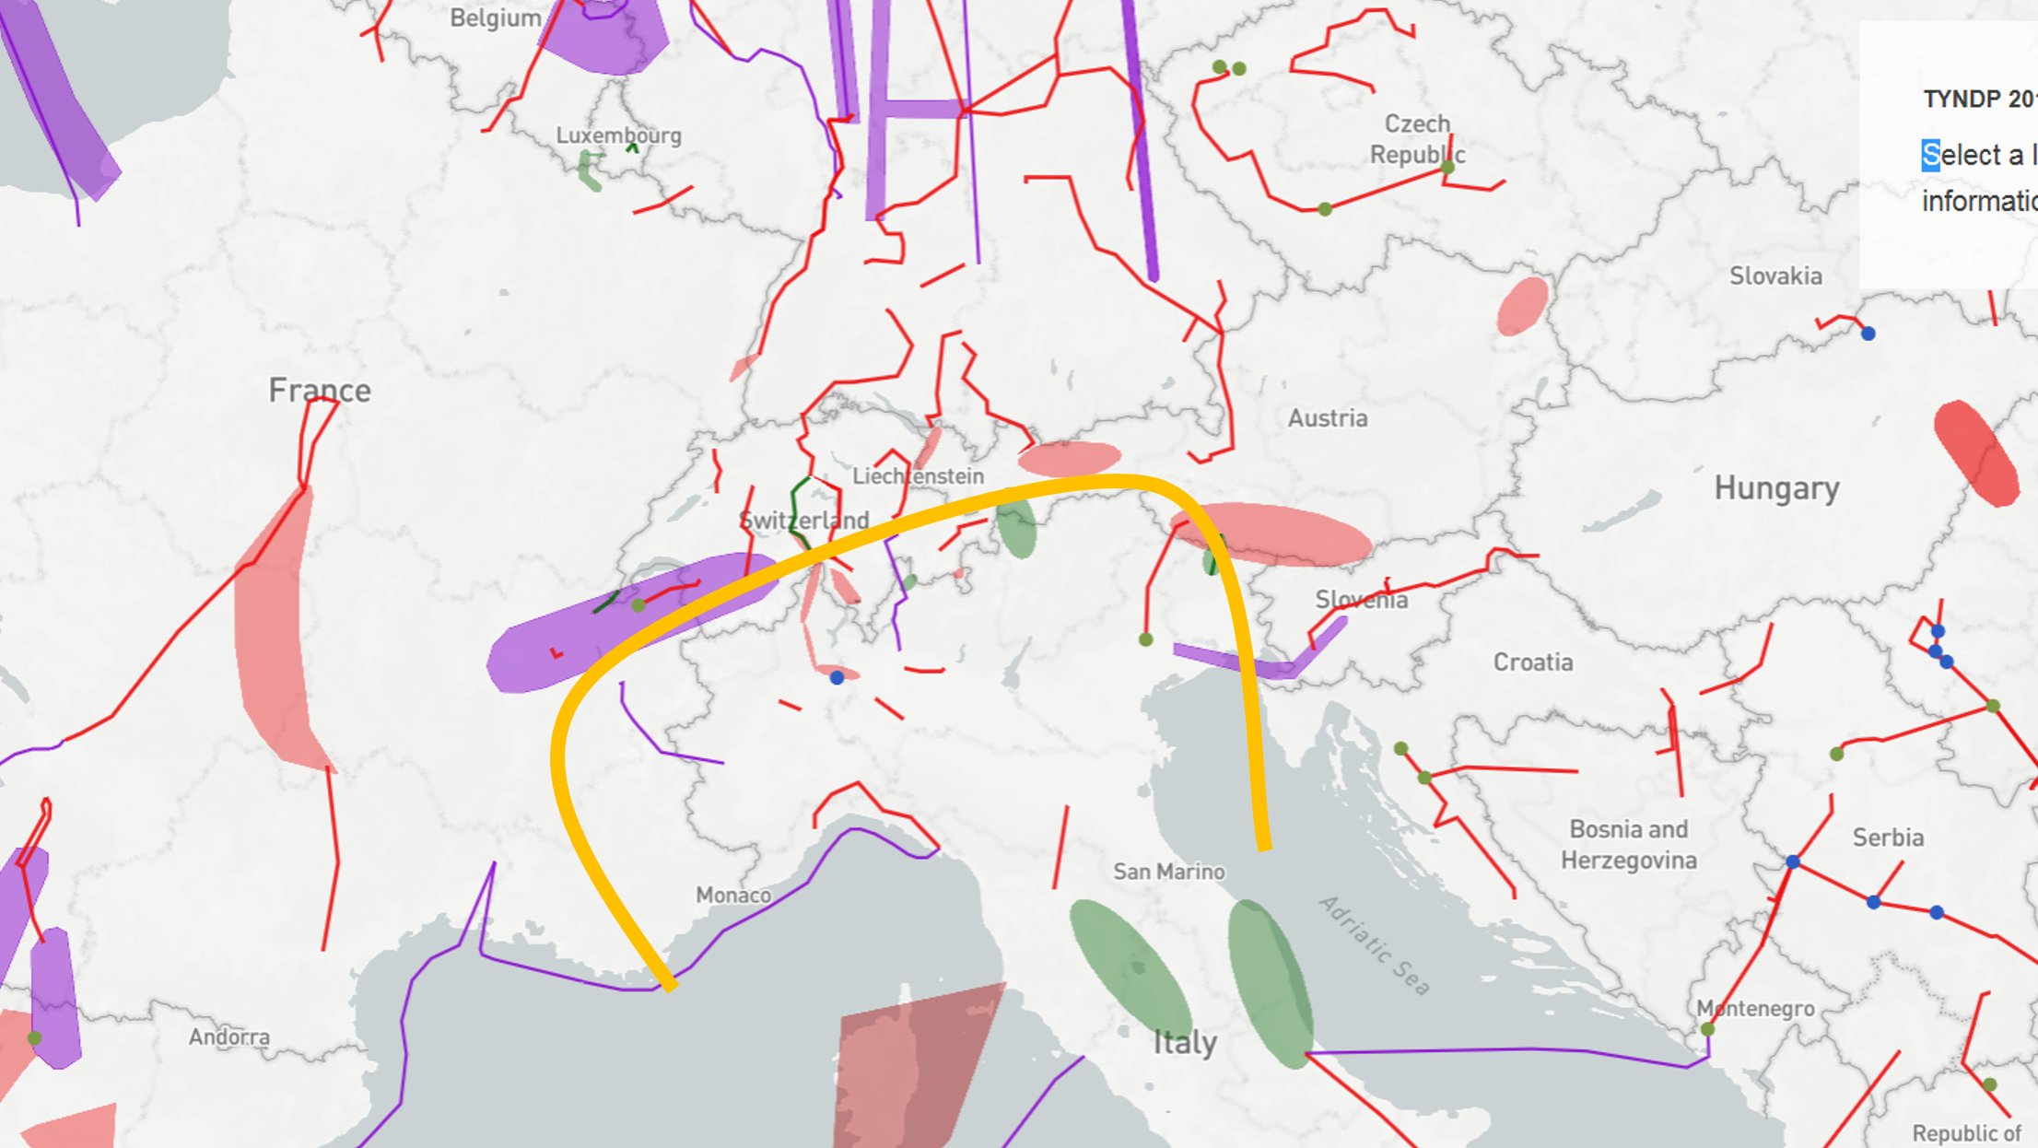

The analyses show that highest SEW/GTC rate is achieved in Vision 2, while the lowest is in Vision 3. The higher SEW/GTC values in the V2 and V1 are substantially related to the low CO2 prices used in such scenarios, that lead to a relevant Italian import according mainly to the value of the demand (higher in V2 than in V1). Conversely, in V3 and V4, the higher CO2 prices and the higher RES generation capacity lead to a different use of the Italian Northern boundary, characterised by a lower SEW, but higher RES integration indicators. It is also relevant to highlight that, according to the curves described below, the 2030 reference capacity due to the projects planned on the Northern Italian boundary is quite close to the optimal transmission capacity in the examined scenarios, meaning that any further increase of GTC cannot provide an equivalent increase of SEW.  
Detailed TYNDP project CBAs show that average SEW contributions per project in the perimeter of the Italian Norther boundary range from 35 to 50 MEuro/year, with higher benefits given by the projects which are commissioned first.

**Welfare and Capacity**

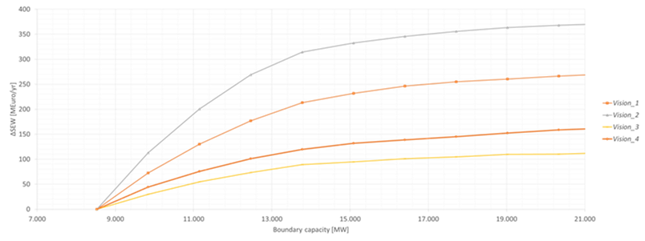

The SEW/GTC curve depicted refers to the impact of reinforcing the interconnection at the North-Italian boundary, the reference capacity reflects the capacity increase on the North Italian Border mainly due to the commissioning of PCI projects. Referring to interconnection Italy Tunisia interconnection promoted by Terna is the project considered mature enough to be included in the reference year 2030 (expected commissioning in 2022). For this reason no related increasing capacities step could be considered concerning this boundary.

**Interconnection target for 2030**

Making the balance between societal welfare gain and infrastructure investment costs for increasing levels of interconnection, the optimal level of interconnection are around 14 GW, which is what the TYNDP portfolio of mid-term and long-term projects aims to deliver.

# **South East integration**

*Strengthening the interconnection between IT/AT/SI/CZ and HR/HU/SK in South East Europe.*

The drivers for investments in this region are integrating high potentials of renewables into a relatively sparse network.

**TYNDP findings**

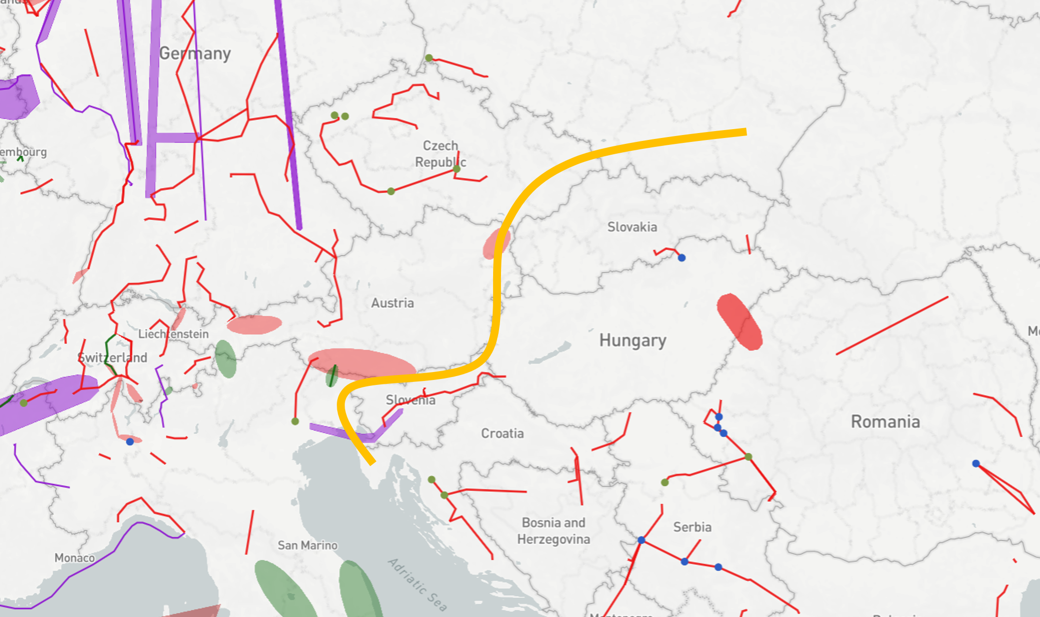

The analyses show the relation between additional capacity increases across these borders and the overall welfare gains as a conservative estimates. Linked with presumed project costs in these areas, the earlier TYNDP studies did not identify relevant investment proposals. Hence, no TYNDP projects are proposed at this stage in the TYNDP.

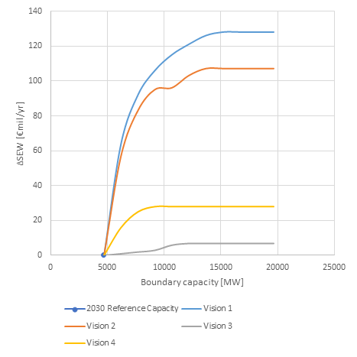

**Interconnection target for 2030**

Making the balance between societal welfare gain and infrastructure investment costs for increasing levels of interconnection, the optimal level of interconnection is around 5 GW. This is in line with the present transmission capacities across this boundary.

# **Eastern Balkan**

*Strengthening the interconnection from BG, RO and GR to the rest of South-East Europe.*

Strengthening the E→W and the N→S corridors is a prerequisite for market integration and the exploitation of the high RES potential in the East part of South-East Europe. Increase of transfer capacity through the boundary at the West borders of Bulgaria and Romania and the North borders of Greece, will allow the increase of exports to West Europe and, through the Balkan, to Italy both from thermal low cost generation in Bulgaria and Romania and from RES installed in Bulgaria, Romania and Greece, depending on the examined Vision.

**TYNDP findings**

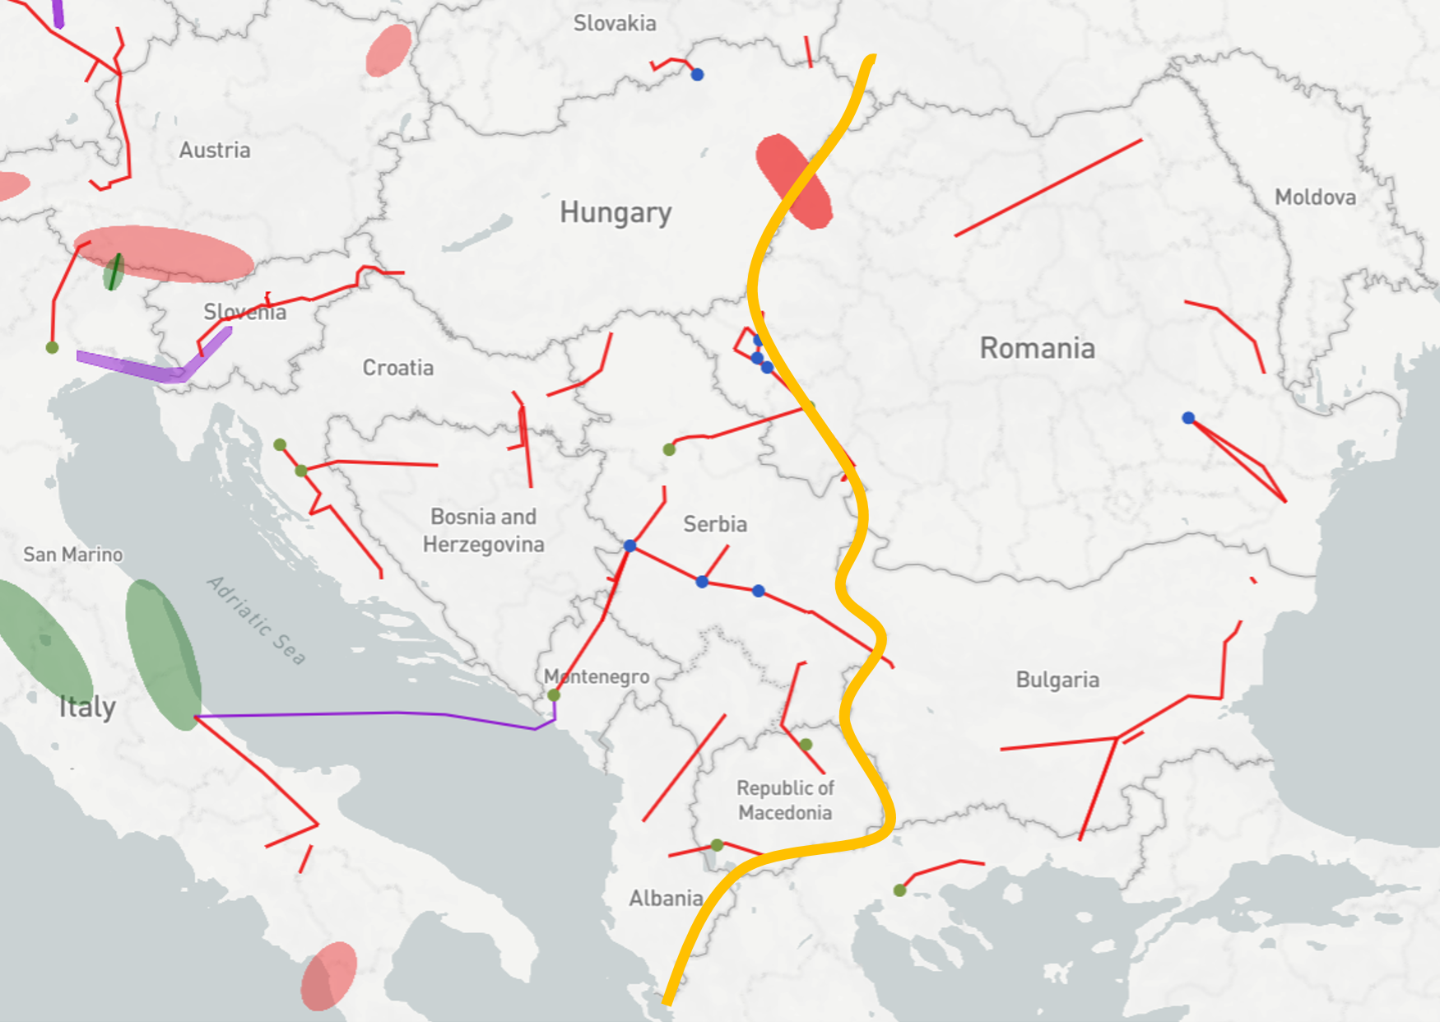

The analyses show that increase of transfer capacity over the examined boundary, results in an increase of societal welfare (ΔSEW) in all visions, up to a certain point where the respective variation curve reaches a saturation region. The highest saturation values for ΔSEW appear in Visions 1 and 4.

Detailed TYNDP project CBAs show that average SEW contributions per project in the perimeter of this boundary range from 20 to 50MEuro/year. This corresponds to about 62 MEuro/year per additional GW of transfer capacity.

**Welfare and Capacity**

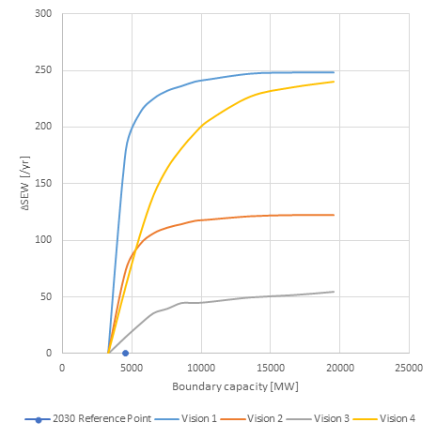

**Interconnection target for 2030**

Making the balance between societal welfare gain and infrastructure investment costs for increasing levels of interconnection, the optimal level of interconnection ranges from 5 GW to 8.5 GW.

Compared to the present and planned investments this shows that in most of the Visions, their implementation will result in a transmission network that is adequate to cope with the expected power flows.